E90 Online UPS
10kVA, 15kVA, 20kVA Models

Service Manual

www.xpcc.com | © 2018 Xtreme Power Conversion Corporation. All rights reserved. (Rev 8/13/18)

Table of Contents
Important Safety Instructions.......................................................................3
Product Description.....................................................................................6
Summarization................................................................................................................................6
Functions and Features...................................................................................................................6
Installation......................................................................................................................................7
E90 Cabinet View Outlook.............................................................................................................10
LCD control Panel..........................................................................................................................13
Installation Notes..........................................................................................................................13
External Protective Devices...........................................................................................................14
Power Cables.................................................................................................................................14
Power Cable Connection...............................................................................................................15
Battery Pack Connection................................................................................................................17
UPS parallel Installation ...............................................................................................................25
Operation..................................................................................................27
Operation Modes.........................................................................................................................27
Turn on/off UPS.............................................................................................................................30
The LCD Display.............................................................................................................................32
Parallel system commissioning......................................................................................................42
Display Messages/Troubleshooting...............................................................................................43

Options ......................................................................................................................................... 45
Specifications............................................................................................47
Problems and Solution..............................................................................48
USB communication port definition.............................................................49
RS232 communication port definition........................................................50
RS485 communication port definition........................................................51
BAT_T communication port definition........................................................52
REPO instruction........................................................................................53
Obtaining Service.......................................................................................54
Xtreme Power Conversion Limited Warranty...............................................55

Product introduction
Summary
E90 Series is a kind of high-frequency online intelligent UPS and adopts double DSP control chips, advanced control
technology and double conversion topology. It eliminates various interference of the grid and makes the output
a stable and pure sine wave power with low noise, no interference and low distortion. With strong load capac-
ity, good load compatibility, wide input voltage and frequency range, excellent generator compatibility and zero
transfer time, it greatly meets the requirement of variety of applications. Comprehensive protection enhances the
stability and reliability of the system. Intelligent battery management, equalized and floating charging auto conver-
sion, battery discharge time prediction and battery self-test can extend the battery life. It can be used in advanced
network systems.
- power range:10KVA-20KVA, up to 4 units can be parallel,
- working mode:High frequency intelligent online (3-phase in to 3-phase out)
- application: Work station, network server, and computer rooms and data center

Features
Three-phase UPS
This E90 series is three-phase in to three-phase out UPS with a large capacity, the three phase input current is
balanced which can balance the load of each phase.
Digital control
Digital control is used for all parts of the UPS, which makes the performance indicators very excellent and the
system more stable. It not only has self-protection and fault diagnosis, but also can avoid risks of analog device
failure, which allows the control system more reliable.
Settable charging current
By setting the battery capacity configured by user, the reasonable charging current can be automatically allo-
cated. Constant voltage charging mode, constant current charging mode and floating charging mode can auto-
switch smoothly.
Intelligent charging method
Advanced two-way, three-stage charging method is adopted. At the first stage, fast recharge with constant large
current to 90% capacity; at the second stage, constant voltage charge can activate the battery characteristics and
make the battery full; at the third stage, floating mode operates. This method can provide a balance between the
fast charge and extended the battery life, which saves the battery investment.
LCD display
Both the LCD and LED display for the series allows the users a more intuitive understanding of the UPS status and
operating parameters such as input/output voltage and frequency, load capacity, battery capacity, temperature
and ect.. All the operation are under the monitoring.
Intelligent monitoring function
When the SNMP is selected with UPS, the remote monitoring can be achieved easily.
EPO function
An emergency power off(EPO) button interface Is embedded in the rear panel of the UPS. The user can add the
EPO button. In case of emergency, press the EPO button to shut down the UPS. It also has remote emergency
power off (REPO) function.

Operating panel

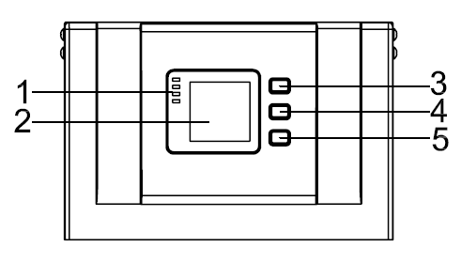
Operating interface

1) LED (from top to bottom: “alarm”, “bypass”, “battery”, “inverter”)
2) LCD display
3) Scroll button
4) Off button
5) On button(battery cold start switch)

Status indicator on front panel, LCD and other buttons
LCD and indicator LED on front panel, cooperate with buttons, can view all the data, information and set
parameters.

Table 1 Indicator description

Name | Status | Description
Alarm LED | Red on | UPS fault and alarm
 | Red off | UPS normal
Bypass LED | Green on | UPS bypass output
 | Green flash | Bypass abnormal or out of range, or bypass switch fail
 | Green off | Bypass normal, no bypass output
Battery LED | Green on | Battery supply power
 | Green flash | Battery discharge termination and pre-inform
 | Green off | Battery abnormal(no battery or battery fail)
Mains output LED | Green on | mains output
 | Green off | no mains output

Table 2 Button description

Button Name | Description
Cycle | Enter the menu to view the UPS data and information
ON | Start inverter  battery cold start under the shutdown
OFF | Shut down inverter in Line mode and transfer to bypass(if bypass normal) ; Shut down inverter under the battery mode, UPS down;  Battery cold start when off status

System block diagram

Bps switch

EMI

EMI

mains

EMI
AC/DC

DC/DC
DC/AC

Output

output

batter
Battery fuse

CHARGER

fuse

Block diagram
As shown above, there is a bypass switch. When switch on it, the power will go to the bypass road. Then UPS will
detect the output switch and bypass voltage, frequency and phase sequence. If output switch is on, both the volt-
age and frequency of bypass are in the range, the UPS will send out bypass output commands and meanwhile the
bypass LED will be on.

Close the main switch, if the mains voltage, frequency and phase sequence are in the range, UPS will soft start. When bus voltage rises around 170V, PFC boost begins to work and the bus voltage will be up to about 200V. Inverter starts. When inverter is ready, it will transfer to inverter mode. If bypass voltage, frequency and phase sequence are normal, the inverter voltage will track the bypass power and switch to inverter output without in- terruption, or the UPS will transfer to inverter intermittently. Inverter LED on and bypass LED off, the inverter will provide power. If the battery is normal, the UPS will activate the charger to charge the battery.

UPS detects maintenance air-switch at any time. When remove the baffle of the switch, UPS will transfer to bypass status. Now close the maintenance air-switch for supplying power from bypass. When finish maintenance, the air- switch cannot be open until the UPS is in bypass, or it will cause the power down of load.

AC/DC & DC/DC principle circuit diagram

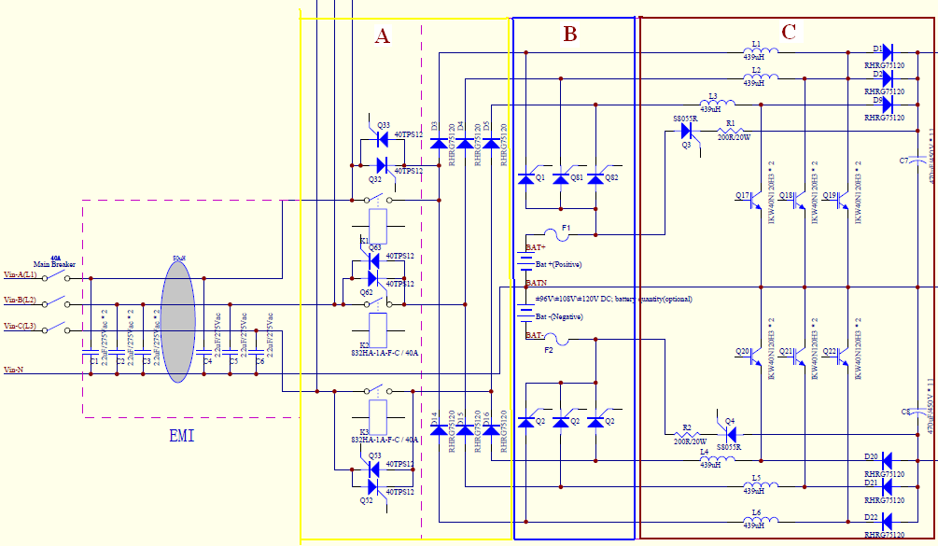

AC/DC & DC/DC principle

As shown above, A (yellow box) shows the rectifier circuit, B (blue box) shows the battery input circuit, C (other part) shows the boost circuit. A and C form the PFC rectifier circuit while B and C form the battery boost circuit

Inverter DC/AC principle

A

B

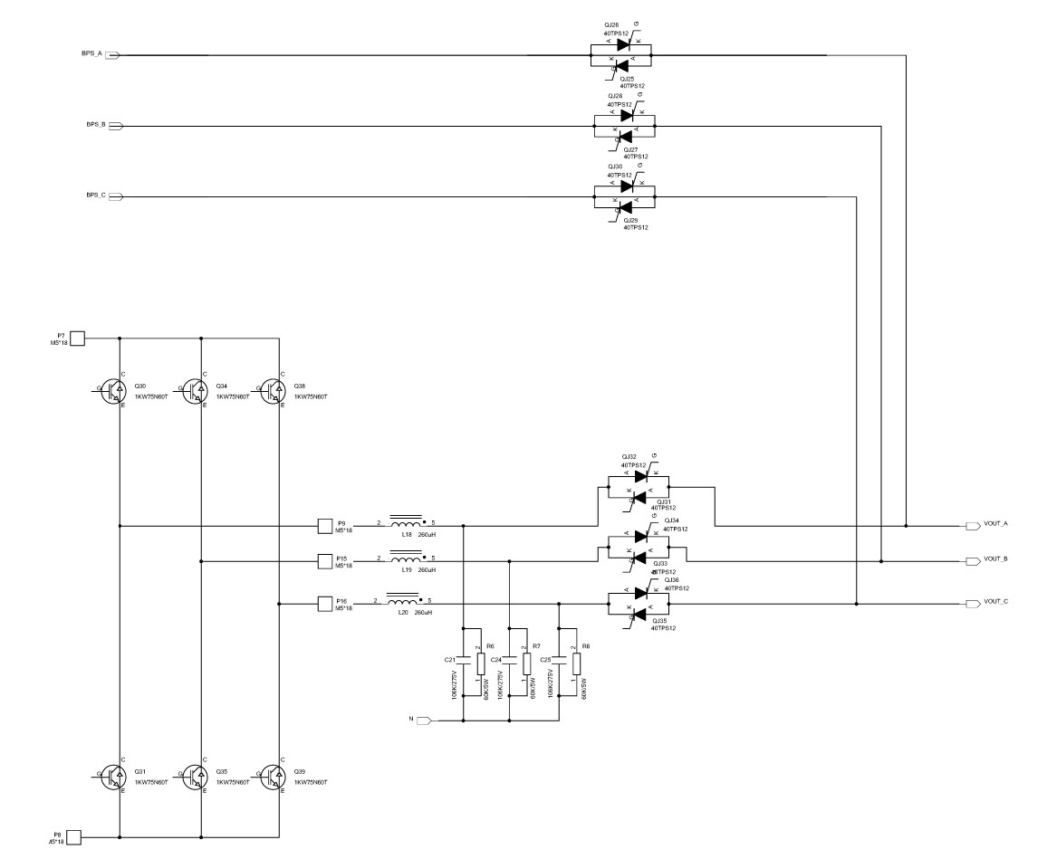Bypass and inverter principle

As shown above, A (yellow box) represents bypass circuit of UPS, B (blue box) shows the inverter circuit, which converts the Bus voltage into the AC output.

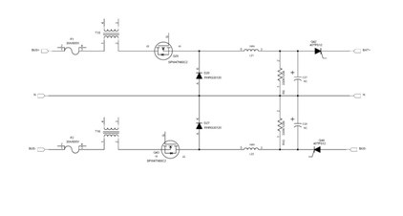Charging principle

Battery

Charging Fuse

As shown above, charger reduces the Bus voltage to a suitable voltage to charge the battery.

Parameters
UPS specification

MODEL NUMBER |  | E90-10K | E90-15K | E90-20K
CAPACITY | Power rating | 10kVA/10kW | 15kVA/15kW | 20kVA/20kW
INPUT | Voltage / Range | 208Y/120VAC or 220Y/127VAC / 125-275VAC three-phase*
INPUT | Frequency | 40–70Hz auto-sensing
OUTPUT | Voltage / Regulation | 208/120VAC or 220/127VAC / ± 1% three-phase
OUTPUT | Frequency | 50/60±0.1%
OUTPUT | Overload capacity | 150% for 1 min, 125% for 10 min, 110% for 60 min
OUTPUT | Efficiency | Up to 94% online mode or 98% ECO mode
BATTERY | Battery Type | Sealed maintenance-lead acid
BATTERY | Battery quantity | Up to (60) 12V 9AH
BATTERY | Charger Voltage / Current | 273VDC / 1A-20A (max) programmable from LCD
PHYSICAL | Dimensions (W x D x H) | 9.8 x 39.2 x 34.0 in
PHYSICAL | Input / Output | Terminal blocks
PHYSICAL | Weight | 296 lbs (1 string) | 419 lbs (2 string) | 539 lbs (3 string)
OPTIONAL BATTERY PACK | Model | EBP80-63A | EBP80-125A
OPTIONAL BATTERY PACK | Battery quantity and size | (80) 12V 9AH
OPTIONAL BATTERY PACK | Dimensions (W x D x H) | 9.8 x 39.2 x 34.0 in
OPTIONAL BATTERY PACK | Weight | 535 lbs
ENVIRONMENT | Operating temperature | 32–104°F (0–40°C)
ENVIRONMENT | Audible noise | <55dB from 1M distance for 10/15kVA; <58dB from 1M distance for 20kVA
ENVIRONMENT | Altitude | 5,200 ft above sea level**
APPROVALS |  | UL, FCC, Energy Star
WARRANTY |  | 2 years electronics, 2 years battery warranty (USA and Canada)
COMMUNICATIONS INTERFACE |  | RS-232, EPO, RS485, USB, dry contact, (2) slots for optional cards (Web/SNMP, Relay/dry  contact)
INCLUDED IN BOX |  | User manual, RS-232 communication cable, USB cable, Muser monitoring software
AVAILABLE OPTIONS |  | External maintenance bypass, output distribution, external battery packs, parallel cables
*Depending on load level. **Battery life is reduced above 30°C, UPS capacity derates above 40°C and 5,200 ft above sea level

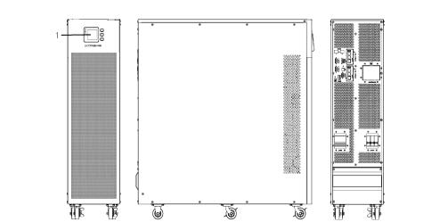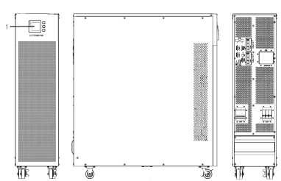E90 Cabinet View Outlook

Front View Side View Rear view

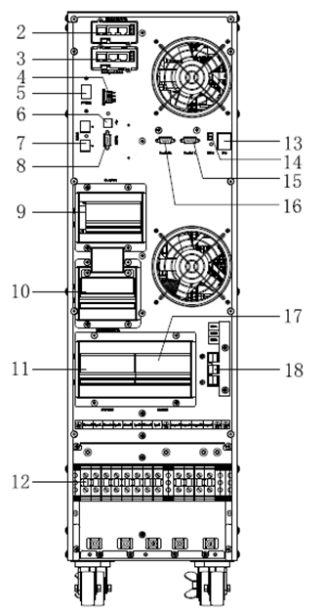

10kVA Rear View (without terminal block cover)

(1)LCD panel | (2) Intelligent Slot 1 (SNMP card/ Relay card)
(3)Intelligent Slot 2 (SNMP card/ Relay card) | (4) Optional dry contact output port
(5)Power Switch | (6) USB port
(7) RS485 port | (8) RS232
(9) O/P Switch | (10) Maintenance switch & its cover
(11) Bypass Switch | (12) Terminal block for Input, output & GND
(13) EPO switch | (14) REPO port
(15) Parallel port 2 | (16) Parallel port 1
(17) I/P Switch | (18) Terminal block for battery

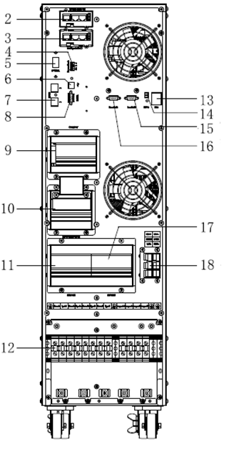
15-20kVA Rear View (without terminal block cover)

(1)LCD panel | (2) Intelligent Slot 1 (SNMP card/ Relay card)
(3)Intelligent Slot 2 (SNMP card/ Relay card) | (4) Optional dry contact output port
(5)Power Switch | (6) USB port
(7) RS485 port | (8) RS232
(9) O/P Switch | (10) Maintenance switch & its cover
(11) Bypass Switch | (12) Terminal block for Input, output & GND
(13) EPO switch | (14) REPO port
(15) Parallel port 2 | (16) Parallel port 1
(17) I/P Switch | (18) Terminal block for battery

Internal view of UPS

PFC power board

EPO interface board

Fan INV power board

Input board

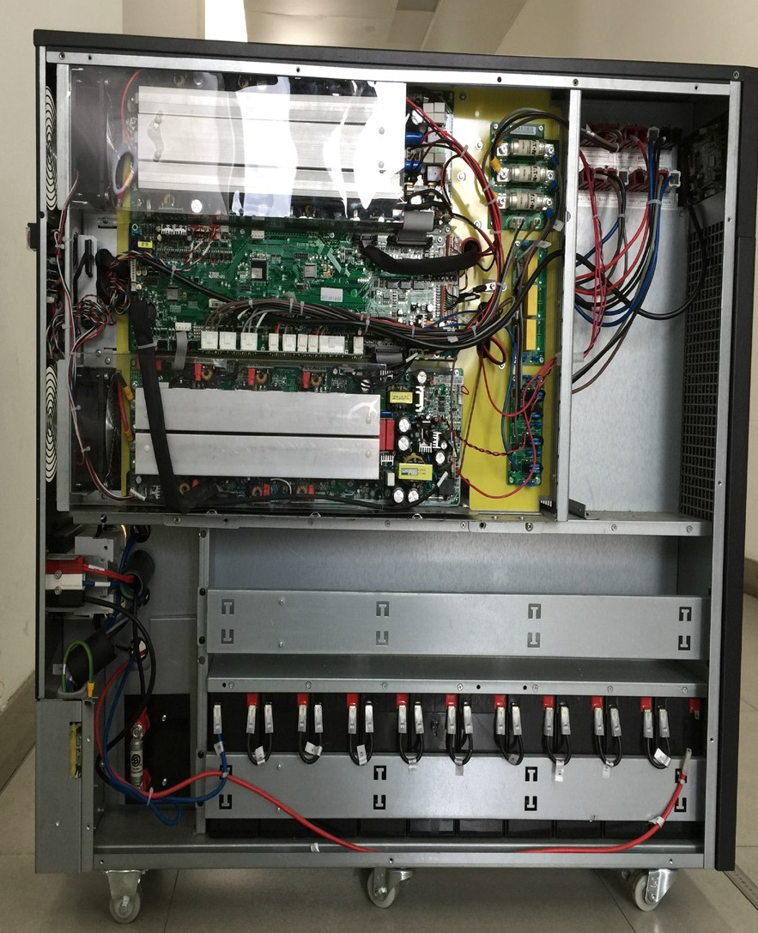UPS left view

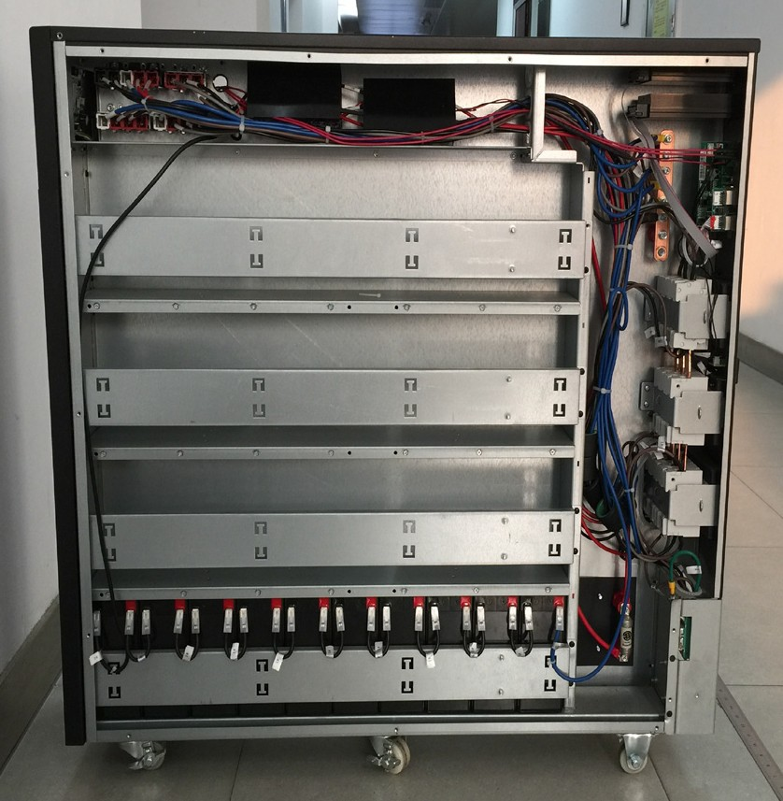Output breaker Maintenance switch Input breaker
Input filter ring

Batteries
Battery fuse

UPS right view

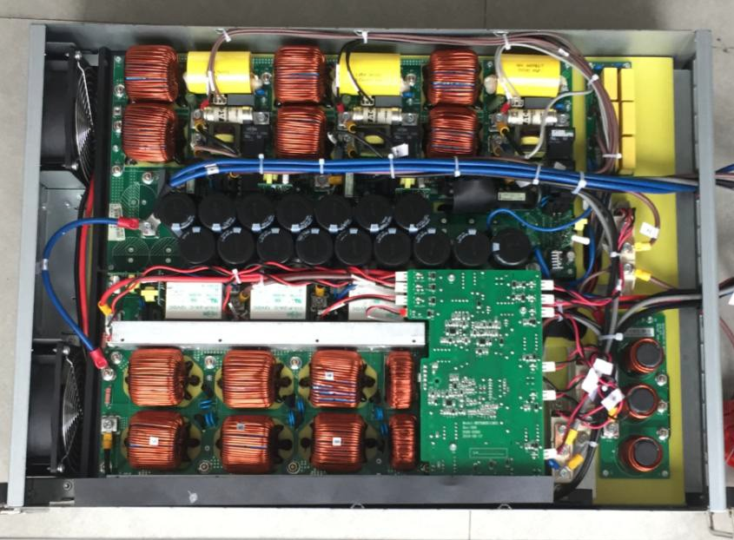INV inductor board

Output EMI board

PFC drive board

PFC inductor board

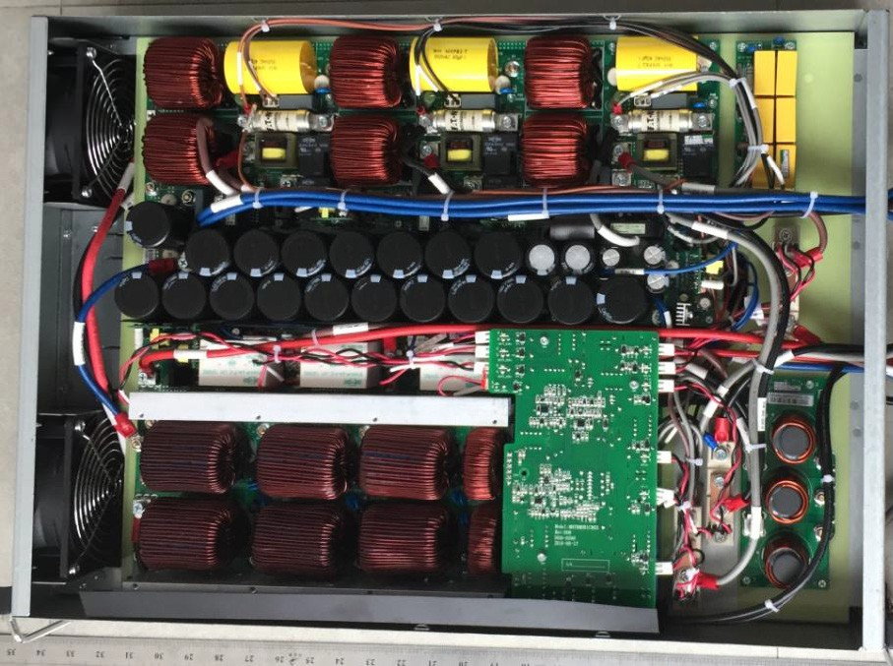
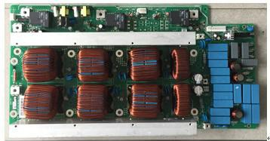UPS module inside view (20KVA)

PFC inductor board(10-15KVA)

6pcs PFC inductors

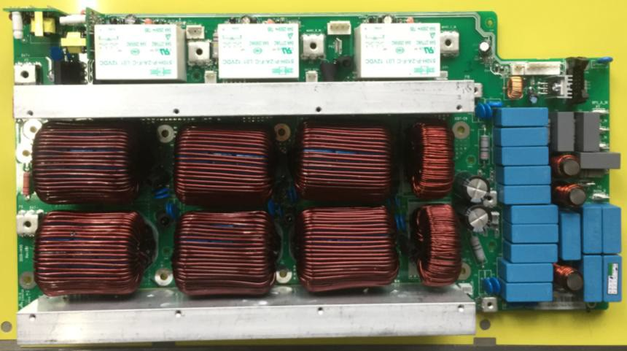2pcs charging
inductors

PFC inductor board(20KVA)

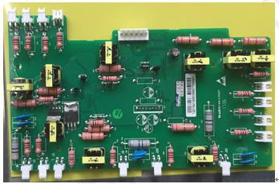

PFC drive board

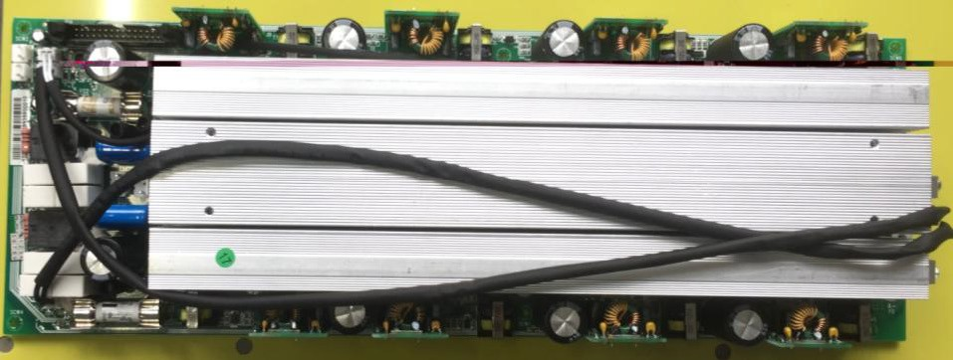Charging fuse IGBT drive board

PFC power board

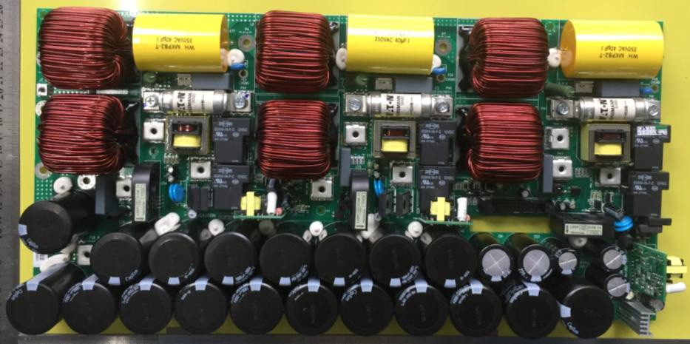6pcs inv. inductors
3pcs inv. capacitors

3pcs inverter fuse

3pcs inverter SCR
drive board

BUS capacitor

Inverter inductor board

Radiator

Auxiliary power

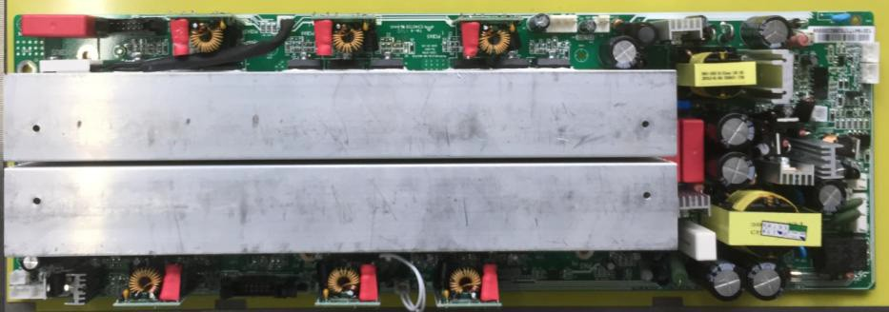INV. Power board

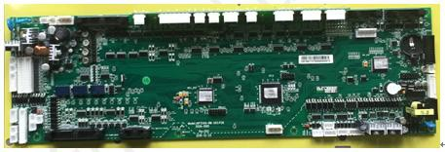

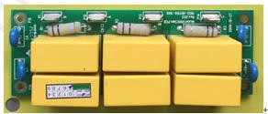Control detection board

Output EMI board

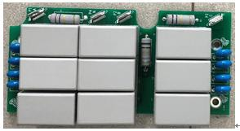

Input EMI board(15-20KVA)

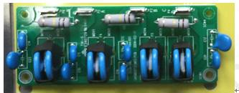
Input board

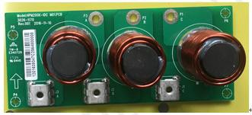

Input filter inductor board

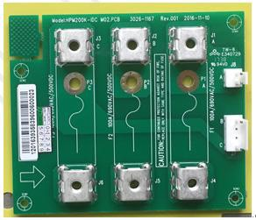

Input fuse board

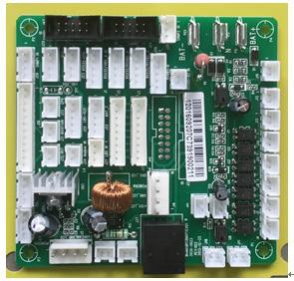

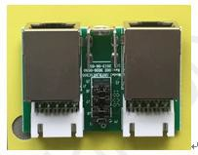Adapter

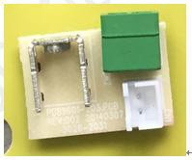RJ45 interface board

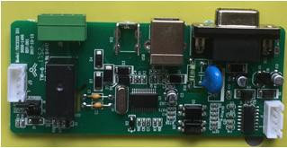EPO interface board

USB interface board

PCB boards and their signals

PFC inductor board
Function overview
- Mains rectifier
- Battery input circuit
- Bypass static switch
- Boost inductor circuit
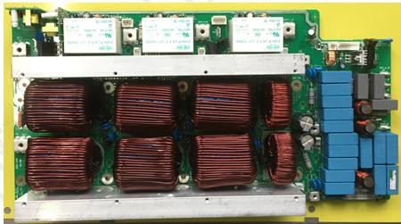- Charging inductor circuit

Input and output interface definition
PFC inductor board interface
PFC inductor board

No. | Definition | Specification | Name | Description
P8 | BAT-  BAT- input | Name:blade terminal  Description: UHTWSZ Wiring copper bar II  welded assemblies plated bright nickel | BAT- | BAT- input
P6 | Assistant power  15V+ | Name: neilsbed  Description: 1121S-2P P=3.96mm 180° single  row square PIN white | Assistant power | 15V+
J1 | PFC drive board  signal | Name: neilsbed  Description: 1121S-6P P=3.96mm 180° single  row square PIN white |  | PFC drive board  signal
P15 | relay/SCR drive signal | Name: neilsbed  Description: 301S-10P P=2.54mm 180° two  rows square PIN black |  | relay/SCR drive signal
P5 | BAT+  BAT+ input | Name: blade terminal  Description: UHTWSZ Wiring copper bar II  welded assemblies plated bright nickel | BAT+ | BAT+ input
P7 | BPS_A_IN Bps A phase input | Name:blade terminal  Description:4PIN 10A M4screw hole straight leg  8*8.4*11.1mm T0.8mm tinned copper | BPS_A_IN | Bps A phase input

No. | Definition | Specification | Name | Description
P21 | CHARGE+ CHARGE- Charging volt- age sample | Name:blade terminal  Description: 1121S-3P P=3.96mm 180° single  row square PIN white | CHARGE+ CHARGE- | Charging voltage sampling
P27 | N Neutral | Name: blade terminal  Description: UHTWSZ Wiring copper bar II  welded assemblies plated bright nickel | N | Neutral
P20 | BPS_B_IN Bps B phase input | Name: blade terminal  Description: 4PIN 10A M4 screw hole straight  leg 8*8.4*11.1mm T0.8mm tinned copper | BPS_B_IN | Bps B phase input
P22 | BPS_C_IN Bps C phase input | Name: blade terminal  Description: 4PIN 10A M4 screw hole straight  leg 8*8.4*11.1mm T0.8mm tinned copper | BPS_C_IN | Bps C phase input
J2 | A  Main A phase  input | Name: blade terminal  Description: 4PIN 10A M4 screw hole straight  leg 8*8.4*11.1mm T0.8mm tinned copper | A | Main A phase input
J13 | B  Main B phase  input | Name: blade terminal  Description: 4PIN 10A M4 screw hole straight  leg 8*8.4*11.1mm T0.8mm tinned copper | B | Main B phase input
J14 | C  Main C phase  input | Name: blade terminal  Description: 4PIN 10A M4 screw hole straight  leg 8*8.4*11.1mm T0.8mm tinned copper | C | Main C phase input
J23 | A  Main A phase  input sampling | Name: neilsbed  Description: 1121S-3P P=3.96mm 180° single  row square PIN white | A | Main A phase input sampling
J24 | B&C  Main B&C  phase input  sampling | Name: neilsbed  Description: 1121S-3P P=3.96mm 180° single  row square PIN white | B&C | Main B&C  phase input sam-  pling
J3 | positive charger  SCR drive | Name: neilsbed  Description: 2001S-2P P=2.54mm 180° single  row square PIN white | CHRG_ SCR+ | positive charger SCR  drive
J4 | Negative char- ger SCR drive | Name: neilsbed  Description: 2001S-2P P=2.54mm 180° single  row square PIN white | CHRG_ SCR- | Negative charger  SCR drive
J9 | Negative battery  SCR drive 1 | Name: neilsbed  Description: 2001S-2P P=2.54mm 180° single  row square PIN white | BAT1- SCR1 | Negative battery  SCR drive 1

PFC drive board
Function overview:
-Bypass SCR drive circuit
-Battery SCR drive circuit
-Charging SCR drive circuit

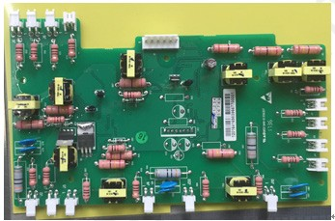
No. | Definition | Specification | Name | Description
J11 | Negative bat- tery SCR drive 2 | Name: neilsbed  Description: 2001S-2P P=2.54mm 180° single  row square PIN white | BAT1-SCR2 | Negative battery  SCR drive 2
J15 | Negative bat- tery SCR drive 3 | Name: neilsbed  Description: 2001S-2P P=2.54mm 180° single  row square PIN white | BAT1-SCR3 | Negative battery  SCR drive 3
J8 | Positive battery  SCR drive 1 | Name: neilsbed  Description: 1121S-2P P=3.96mm 180° single  row square PIN white | BAT1+SCR | Positive battery SCR  drive 1
J10 | Positive battery  SCR drive 2 | Name: neilsbed  Description: 1121S-2P P=3.96mm 180° single  row square PIN white | BAT2+SCR | Positive battery SCR  drive 2
J12 | Positive battery  SCR drive 3 | Name: neilsbed  Description: 1121S-2P P=3.96mm 180° single  row square PIN white | BAT3+SCR | Positive battery SCR  drive 3

Figure 33.PFC drive board interface

Input and output interface definition
PFC drive board interface description

No. | Definition | Specification | Name | Description
J1 | PFC drive board  signal | Name: neilsbed  Description: 1121S-6P P=3.96mm 180°  single row square PIN white |  | PFC drive board  signal
J13 | positive charger  SCR drive | Name: neilsbed  Description: 2001S-2P P=2.54mm 180°  single row square PIN white | CHRG_SCR+ | positive charger SCR  drive
J14 | negative charger  SCR drive | Name: neilsbed  Description: 2001S-2P P=2.54mm 180°  single row square PIN white | CHRG_SCR- | negative charger  SCR drive
J9 | negative battery  SCR drive1 | Name: neilsbed  Description: 2001S-2P P=2.54mm 180°  single row square PIN white | BAT1-SCR1 | negative battery SCR  drive1
J11 | negative battery  SCR drive2 | Name: neilsbed  Description: 2001S-2P P=2.54mm 180°  single row square PIN white | BAT1-SCR2 | negative battery SCR  drive2
J12 | negative battery  SCR drive3 | Name: neilsbed  Description: 2001S-2P P=2.54mm 180°  single row square PIN white | BAT1-SCR3 | negative battery SCR  drive3
J23 | bypass SCR  drive signal | Name: neilsbed  Description: 2001S-2P P=2.54mm 180°  single row square PIN white | BPS_B_RLY | bypass SCR drive signal
J6 | positive battery  SCR drive1 | Name: neilsbed  Description: 1121S-2P P=3.96mm 180°  single row square PIN white | BAT1+SCR | positive battery SCR  drive1
J7 | positive battery  SCR drive2 | Name: neilsbed  Description: 1121S-2P P=3.96mm 180°  single row square PIN white | BAT2+SCR | positive battery SCR  drive2
J8 | positive battery  SCR drive3 | Name: neilsbed  Description: 1121S-2P P=3.96mm 180°  single row square PIN white | BAT3+SCR | positive battery SCR  drive3
J2 | A phase bypass  SCR1 drive | Name: neilsbed  Description: 1121S-2P P=3.96mm 180°  single row square PIN white | BPS_A_SCR1 | A phase bypass  SCR1 drive
J3 | A phase bypass  SCR2 drive | Name: neilsbed  Description: 1121S-2P P=3.96mm 180°  single row square PIN white | BPS_A_SCR2 | A phase bypass  SCR2 drive
J4 | B phase bypass  SCR1 drive | Name: neilsbed  Description: 1121S-2P P=3.96mm 180°  single row square PIN white | BPS_B_SCR1 | B phase bypass  SCR1 drive
J5 | B phase bypass  SCR2 drive | Name: neilsbed  Description: 1121S-2P P=3.96mm 180°  single row square PIN white | BPS_B_SCR2 | B phase bypass  SCR2 drive
J10 | C phase bypass  SCR drive1 | Name: neilsbed  Description: 1121S-2P P=3.96mm 180°  single row square PIN white | BPS_C_SCR1 | C phase bypass SCR1  drive

No. | Definition | Specification | Name | Description
J20 | C phase bypass  SCR drive2 | Name: neilsbed  Description: 1121S-2P P=3.96mm 180° single  row square PIN white | BPS_C_  SCR2 | C phase bypass  SCR2 drive

PFC power board
Function overview:
-Boost circuit IGBT
-Charging circuit MOSFET
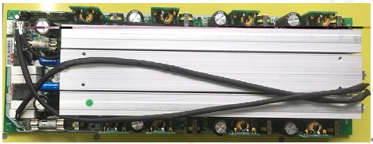-Battery soft start resistor

Input and output interface definition
PFC power board interface
PFC power board

No. | Definition | Specification | Name | Description
P6 | Assistant power  15V+ | Name: neilsbed  Description: 1121S-2P P=3.96mm 180° single  row square PIN white | Assistant power | 15V+
P9 | BUS+ | Name: blade terminal  Description: 4PIN 10A M4 screw hole straight  leg 8*8.4*11.1mm T0.8mm tinned copper | BUS+ | BUS+
P10 | BUS- | Name: blade terminal  Description: 4PIN 10A M4 screw hole straight  leg 8*8.4*11.1mm T0.8mm tinned copper | BUS- | BUS-
P14 | PFC/charger drive signal | 301S-30P P=2.54mm 180° two rows square PIN  black horn |  | PFC/charger drive signal
P20 | Assistant power  15V+ | Name: neilsbed  Description: 1121S-2P P=3.96mm 180° single  row square PIN white | Assistant power | 15V+
P22 | BAT+/BAT- battery cold start power | Name: neilsbed  Description: 1121S-3P P=3.96mm 180° single  row square PIN white | BAT+/BAT- | battery cold start  power
J18 | BUS+/BUS- BUS+/BUS- Voltage detec- tion | Name: neilsbed  Description: 1121S-3P P=3.96mm 180° single  row square PIN white | BUS+/ BUS- | BUS+/BUS-

No. | Definition | Specification | Name | Description
J25 | BAT+/BAT- BAT+/BAT- Voltage detec- tion | Name: neilsbed  Description: 1121S-3P P=3.96mm 180° single  row square PIN white | BAT+/BAT- | BAT+/BAT-  Voltage detection

INV. Inductor board
Function overview”
-INV LC filter
-Output current detection
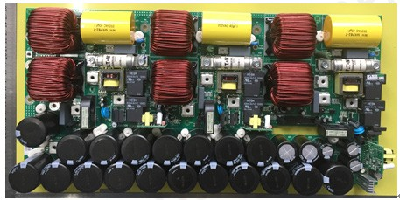-Inv. inductor current detection

Inv. Inductor board

Input and output interface definition
Inductor board interface

No. | Definition | Specification | Name | Description
P2 | VOUT_A  Output A phase | Name: blade terminal  Description: 4PIN 10A M4screw hole straight  leg 8*8.4*11.1mm T0.8mm tinned copper | VOUT_A | Output A phase
P3 | BPS_A  Bypass A phase  Output | Name: blade terminal  Description: 4PIN 10A M4screw hole straight  leg 8*8.4*11.1mm T0.8mm tinned copper | BPS_A | Bypass A phase  Output
P5 | BPS_B  Bypass B phase  Output | Name: blade terminal  Description: 4PIN 10A M4screw hole straight  leg 8*8.4*11.1mm T0.8mm tinned copper | BPS_B | Bypass B phase  Output
P6 | VOUT_B  Output B phase | Name: blade terminal  Description: 4PIN 10A M4screw hole straight  leg 8*8.4*11.1mm T0.8mm tinned copper | VOUT_B | Output B phase
P8 | BPS_C  Bypass C phase  Output | Name: blade terminal  Description: 4PIN 10A M4screw hole straight  leg  8*8.4*11.1mm T0.8mm tinned copper | BPS_C | Bypass C phase  Output

No. | Definition | Specification | Name | Description
P9 | VOUT_C  Output C phase | Name: blade terminal  Description: 4PIN 10A M4screw hole  straight leg 8*8.4*11.1mm T0.8mm  tinned copper | VOUT_C | Output C  phase
P12 | N Neutral | Name: blade terminal  Description: UHTWSZ Wiring copper bar II  welded assemblies plated bright nickel | N | Neutral
P25 | N Neutral | Name: blade terminal  Description: UHTWSZ Wiring copper bar II  welded assemblies plated bright nickel | N | Neutral
P29 | N Neutral | Name: blade terminal  Description: UHTWSZ Wiring copper bar II  welded assemblies plated bright nickel | N | Neutral
P40 | PH2_INV_FUSE-P2  B phase inv.fuse | Name: blade terminal  Description: UHTWSZ Wiring copper bar II  welded assemblies plated bright nickel | PH2_INV_FUSE-  P2 | B phase inv.  fuse
P42 | PH3_INV_FUSE-P2  C phase inv.fuse | Name: blade terminal  Description: UHTWSZ Wiring copper bar II  welded assemblies plated bright nickel | PH3_INV_FUSE-  P2 | C phase inv.  fuse
P44 | PH1_INV_FUSE-P2  A phase inv.fuse | Name: blade terminal  Description: UHTWSZ Wiring copper bar II  welded assemblies plated bright nickel | PH1_INV_FUSE-  P2 | A phase inv.  fuse
J1 | PH1_INV_Q_ C1E2&VOUT_A  A phase inv.DC com- ponent and Output voltage sampling | Name:neilsbed  Description:1121S-4P P=3.96mm 180°  single row square PIN white | PH1_INV_Q_ C1E2&VOUT_A | A phase inv.  DC component  and Output  voltage sam-  pling
J2 | PH2_INV_Q_ C1E2&VOUT_B  B phase inv.DC com- ponent and Output voltage sampling | Name: neilsbed  Description: 1121S-4P P=3.96mm 180°  single row square PIN white | PH2_INV_Q_ C1E2&VOUT_B | B phase inv.  DC component  and Output  voltage sam-  pling
J3 | PH3_INV_Q_ C1E2&VOUT_C  C phase inv.DC com- ponent and Output voltage sampling | Name: neilsbed  Description: 1121S-4P P=3.96mm 180°  single row square PIN white | PH3_INV_Q_ C1E2&VOUT_C | C phase inv.  DC component  and Output  voltage sam-  pling
J4 | INV SCR drive/output current detection signal | Name: neilsbed  Description: 301S-26P P=2.54mm 180°  two rows square PIN black horn |  | INV SCR drive/ output cur- rent detection signal

Inverter power board
Function overview:
-Auxiliary power
-Half-bridge inverter circuit
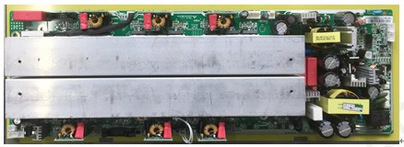-Fan speed regulation circuit

Inverter power board

Input and output interface definition
Inv. Power board interface

No. | Definition | Specification | Name | Description
P9 | +DCBUS  +BUS voltage | Name: blade terminal  Description: 4PIN 10A M4 screw hole  straight leg 8*8.4*11.1mm T0.8mm  tinned copper | +DCBUS | +BUS voltage
P10 | -DCBUS  -BUS voltage | Name: blade terminal  Description: 4PIN 10A M4 screw hole  straight leg 8*8.4*11.1mm T0.8mm  tinned copper | -DCBUS | -BUS voltage
P13 | 15V/-15V ASSISTANT POWER | Name: neilsbed  Description: 1121S-2P P=3.96mm 180°  single row square PIN white | +15V/-15V | ASSISTANT POWER
P28 | +24V_FAN  Fan power | Name: neilsbed  Description: 1121S-2P P=3.96mm 180°  single row square PIN white | +24V_FAN | Fan power
J4 | VBPS_A/BAT+/VINV_A Supply power from auxiliary power | Name: neilsbed  Description: 1121S-5P P=3.96mm 180°  single row square PIN white (remove 2  4PIN) | VBPS_A/BAT+/ VINV_A | Supply power from auxiliary power
J5 | REC_THERMAL_ SWITCH  REC temperature de- tection | Name:neilsbed  Description:2001S-2P P=2.54mm 180°  single row square PIN white | REC_THERMAL_ SWITCH | REC tempera- ture detection
J6 | upper half bridge INV  drive signal | Name:neilsbed  Description:301S-12P P=2.54mm 180°  two rows square PIN black horn |  | upper half bridge INV drive signal

No. | Definition | Specification | Name | Description
J7 | ASSISTANT POWER  +15V/-15V | Name:neilsbed  Description:1121S-4P P=3.96mm 180°  single row square PIN white | ASSISTANT POWER | +15V/-15V
J8 | ON  Start up signal button | Name:neilsbed  Description:2001S-2P P=2.54mm 180°  single row square PIN white | -ON | Start up signal button
J9 | REC_THERMAL_ SWITCH  REC temperature de- tection | Name:neilsbed  Description:2001S-2P P=2.54mm 180°  single row square PIN white | REC_THERMAL_ SWITCH | REC tempera- ture detection
J10 | lower half bridge INV  drive signal | Name:neilsbed  Description:301S-10P P=2.54mm 180°  two rows square PIN black horn | +24V_FAN | lower half bridge INV drive signal
J18 | +24_CSU monitoring unit POWER | Name:neilsbed  Description:1121S-2P P=3.96mm 180°  single row square PIN white | +24_CSU | monitoring unit POWER

DSP board
Function overview:
-UPS control
-Communication circuit
-Parallel circuit
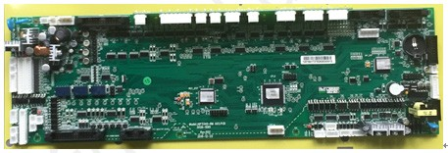-Display circuit

DSP board

Input and output interface definition
Table 9 DSP board interface

No. | Definition | Specification | Name | Description
J7 | ASSISTANT POWER  +15V/-15V | Name:neilsbed  Description:1121S-4P P=3.96mm 180°  single row square PIN white | ASSISTANT POWER | +15V/-15V
J1 | A phase INV voltage/ output voltage sam- pling signal | Name:neilsbed  Description:1121S-5P P=3.96mm 180°  single row square PIN white | Vinv_A/  Vout_A | A phase INV volt- age/output voltage sampling signal
J2 | B phase INV voltage/ output voltage sam- pling signal | Name:neilsbed  Description:1121S-5P P=3.96mm 180°  single row square PIN white | Vinv_B/  Vout_B | B phase INV volt- age/output voltage sampling signal

No. | Definition | Specification | Name | Description
J3 | C phase INV voltage/ output voltage sam- pling signal | Name:neilsbed  Description:1121S-5P P=3.96mm 180°  single row square PIN white | Vinv_C/Vout_C | C phase INV voltage/output voltage sam- pling signal
P20 | Assistant power  15V+ | Name:neilsbed  Description:1121S-2P P=3.96mm 180°  single row square PIN white | Assistant power | 15V+
P21 | charging voltage sam- pling | Name:neilsbed  Description:1121S-3P P=3.96mm 180°  single row square PIN white | CHARGE+/- | charging volt- age sampling
J23 | input voltage sampling | Name:neilsbed  Description:1121S-3P P=3.96mm 180°  single row square PIN white | Vin_A/Vin_N | input voltage sampling
J24 | input voltage sampling | Name:neilsbed  Description:1121S-3P P=3.96mm 180°  single row square PIN white | Vin_B/Vin_C | input voltage sampling
J26 | bypass voltage sam- pling | Name:neilsbed  Description:1121S-8P P=3.96mm 180°  single row square PIN white | Vbps_A/ Vibps_N/ Vbps_B/ Vbps_C | bypass voltage sampling
J25 | battery voltage sam- pling | Name:neilsbed  Description:1121S-3P P=3.96mm 180°  single row square PIN white | Vbat+/Vbat- | battery voltage sampling
J18 | BUS voltage sampling | Name:neilsbed  Description: 1121S-3P P=3.96mm 180°  single row square PIN white | Vbus+/Vbus- | BUS voltage sampling
J17 | parallelsignal1 | Name: neilsbed  Description: 2001S-13P P=2.54mm 180°  single row square PIN white |  | parallelsignal1
J19 | parallelsignal2 | Name: neilsbed  Description: 2001S-13P P=2.54mm 180°  single row square PIN white |  | parallelsignal2
J12 | monitor& communica- tion signal | Name: neilsbed  Description: 2001S-13P P=2.54mm 180°  single row square PIN white |  | monitor& communica- tion signal
CN3 | LCD display signal | Name: neilsbed  Description: 302NS-16P P=2.54mm 180°  two rows square PIN black |  | LCD display signal
P14 | PFC drive signal | Name:neilsbed  Description:301S-30P P=2.54mm 180°  two rows square PIN black horn |  | PFC drive  signal
J4 | INV. inductor board INV. SCR drive/out- put current detection signal | Name:neilsbed  Description:301S-26P P=2.54mm 180°  two rows square PIN black horn |  | INV. inductor board INV. SCR drive/output current detec- tion signal

No. | Definition | Specification | Name | Description
J6 | upper half bridge INV  drive signal | Name:neilsbed  Description:301S-12P P=2.54mm 180°  two rows square PIN black horn | ASSISTANT POWER | upper half bridge  INV drive signal
J10 | lower half bridge INV  drive signal | Name:neilsbed  Description:301S-10P P=2.54mm 180°  two rows square PIN black horn | Vinv_A/  Vout_A | lower half bridge  INV drive signal

Output EMI board
Function overview:
-Output EMI

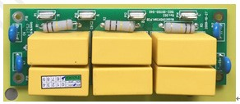
Output EMI board interface

Input and output interface definition
Table 10 output EMI board interface

No. | Definition | Specification | Name | Description
P1 | N | Name:blade terminal  Description:copper tinning 1PIN 10A W=6.3mm  T=0.8mm | N | Neutral
P10 | A | Name:blade terminal  Description:copper tinning 1PIN 10A W=6.3mm  T=0.8mm | A | output A phase
P12 | B | Name:blade terminal  Description:copper tinning 1PIN 10A W=6.3mm  T=0.8mm | B | output B phase
P14 | C | Name:blade terminal  Description:copper tinning 1PIN 10A W=6.3mm  T=0.8mm | C | output C phase

Input EMI board(10-20KVA)
Function overview:
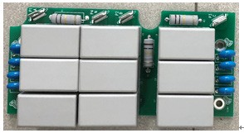-Input EMI

Figure 18.Input EMI board interface(15/20KVA) Input and output interface definition
Table 11 output EMI board interface
No. | Definition | Specification | Name | Description
P4 | N | Name:blade terminal  Description:4PIN 10A M4 screw hole straight leg  8*8.4*11.1mm T0.8mm tinned copper | N | N
P1 | Vin-A | Name:blade terminal  Description:UHTWSZ Wiring copper bar II welded  assemblies plated bright nickel | Vin-A | Input A phase
P2 | Vin-B | Name:blade terminal  Description:UHTWSZ Wiring copper bar II welded  assemblies plated bright nickel | Vin-B | Input B phase
P3 | Vin-C | Name:blade terminal  Description:UHTWSZ Wiring copper bar II welded  assemblies plated bright nickel | Vin-C | Input C phase

Adapter board
Function overview:
-Signal adapter function

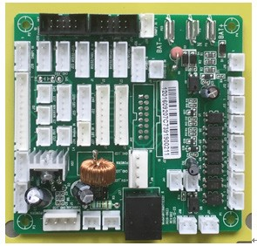

adapter interface

Input and output interface definition
Table 12 adapter board interface
No. | Definition | Specification | Name | Description
J24 | SNMP/ relay signal | Name:neilsbed  Description:302NS-10P P=2.54mm 180° two  rows square PIN black | SNMP2 | SNMP/ relay signal
J47 | SNMP/ relay signal | Name:neilsbed  Description:302NS-10P P=2.54mm 180° two  rows square PIN black | SNMP1 | SNMP/ relay signal
J1 | RS232/485_A  signal | Name:blade terminal  Description:2001S-5P P=2.54mm 180° single  row square PIN white | RS232/485_A IN | RS232/485_A signal
J22 | 485_A signal | Name:blade terminal  Description:2001S-5P P=2.54mm 180° single  row square PIN white | BAT_T(485_A) | 485_A signal
J23 | RS232(USB)  signal | Name:blade terminal  Description:2001S-5P P=2.54mm 180° single  row square PIN white | RS232-USB | RS232(USB) signal
J28 | SNMP1 signal | Name:blade terminal  Description:2001S-5P P=2.54mm 180° single  row square PIN white | SNMP1 IN | SNMP1 signal
J39 | SNMP2 signal | Name:blade terminal  Description:2001S-5P P=2.54mm 180° single  row square PIN white | SNMP2 IN | SNMP2 signal

RJ45 interface board
Function overview:
-signal interface function

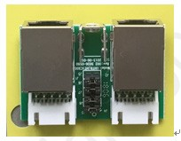
Figure 20.RJ45 interface board interface

Input and output interface definition
Table 13 RJ45 interface board interface

No. | Definition | Specification | Name | Description
J3 | RJ45_1 signal | Name:neilsbed  Description:2001R-5P P=2.54mm 90° single  row square PIN white | RJ45_1 | RJ45_1 signal
J4 | RJ45_2 signal | Name:neilsbed  Description:2001R-5P P=2.54mm 90° single  row square PIN white | RJ45_2 | RJ45_2 signal
J1 | RJ45_1 signal | Name:PC interface  Description:RJ45 female 8PIN black 90°  metal shell | RJ45_1 | RJ45_1 signal
J2 | RJ45_2 signal | Name:PC interface  Description:RJ45 female 8PIN black 90°  metal shell | RJ45_2 | RJ45_2 signal

EPO interface board
Function overview:
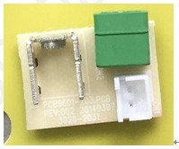-signal interface function

Input and output interface definition
EPO interface board interface

Table 14 EPO interface board interface

No. | Definition | Specification | Name | Description
CN1 | EPO signal | Name:neilsbed  Description:2001S-2P P=2.54mm 180° single  row square PIN white | EPO | EPO signal
CN2 | EPO signal | Name:neilsbed Description:PLTBH1.5-2-S-3.8 12PIN P=3.81mm 90° square PIN green (male) | EPO | EPO signal

EPO interface board
Function overview:
-signal interface function

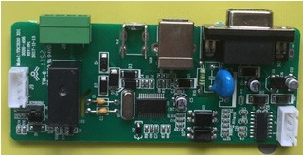
USB interface board interface

Input and output interface definition
Table 15 USB interface board interface
No. | Definition | Specification | Name | Description
J1 | RS232(USB)  signal | Name:neilsbed  Description:2001S-4P P=2.54mm 180° single  row square PIN white | EPO | EPO signal
J8 | Dry contact signal | Name:neilsbed  Description:2001S-4P P=2.54mm 180° single  row square PIN white | Dry Contact | Dry contact signal
J2 | RS232 signal | Name:neilsbed  Description:2001S-4P P=2.54mm 180° single  row square PIN white | RS232 | RS232 signal
USB | USB signal | Name:PC interface  Description:USB interface female 6PIN black  square 90° | USB | USB signal

Parallel interface board
Function overview:
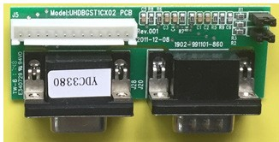-External parallel signal interface function

Figure 23.parallel interface board interface

Input and output interface definition
Table 16 parallel interface board interface

No. | Definition | Specification | Name | Description
J5 | Parallel signal | Name:neilsbed  Description:2001S-13P P=2.54mm 180° single  row square PIN white | Parallel signal | Parallel signal
J20 | Parallel sig-  nal1 | Name:PC interface  Description:DB15 male P=2.29mm black 90° | Parallel signal1 | Parallel signal1
J28 | Parallel sig-  nal2 | Name:PC interface  Description:DB15 female P=2.29mm black 90° | Parallel signal2 | Parallel signal2

Inspection before installation

Room environment inspection
UPS room:
UPS should be installed in a cool, dry, clean and well-ventilated environment, such as the room
temperature should be < 40°C, the humidity≤95% when 20°C, no dust on the floor, especially without
any conductive powder. The room air cannot contain acid mist or other conductive medium. For detail,
please refer to the users’ manual and other specifications.
Battery room:
The battery should be also placed in a cool, dry, clean and well-ventilated environment. The available
temperature is 15°C-25°C, typically is 20°C. The place where the battery located should keep the
constant temperature and far away from heat and vents.

UPS location inspection
The users’ manual offers the detailed installation instruction, it can be referred for installation.
Check if enough space is left for maintenance operation, ensure that the operator can still pass
through freely when the door is fully opened.
There is no obstruction in the front, above and below of UPS. Enough space should be left for
ventilation.
Air is primarily comes from front door, so check if the front door leave enough air inlet space.

UPS visual inspection
Particularly important: it is necessary to have a comprehensive inspection of internal and
external of UPS
1. Check the external power cable connection(include input /Output phase sequence
battery polarity, fasten bolt and ect.)
2. Check if the parallel cables are connected well? If they are routed separately from power cables?
3. Check if the external signal of the battery box and LBS (when needed) connections are good or
correct?
4. Check if the internal signal cable is connected well, if the cable is loosed by shaking it gently
5. Check if the internal boards or components are disconnected or damaged?

External cables and switch capacity inspection
• For power cable selection and connection method, please refer to the user manual and related specifica-
tion.
• Check if the breakers rated capacity of UPS input, Output and distribution cabinet are appropriate.
• Pay attention to the Neutral and Ground protection inspection:
• If the Neutral and Ground cable size meets the requirement?
• Neutral has separate input and output, connect to the same Neutral is not allowed.
• Check and confirm all the cabinets and cable ducts have been grounded according to the local provisions.
• If the bypass has different power source, please check if the short copper-bar of the internal mains and
bypass has been removed, do the connection correctly according to the users’ manual.
• If the battery breaker box is provided, check if the connection of it is correct.
• Check if the UPS input/output wiring is reasonable and the cable is not in contact with any sharp edges of
objects.
• If the user install the remote contact to realize the EPO function, make sure that the EPO cable is not inter-
ference by other main power signals to avoid UPS malfunction. About how to realize the EPO function by
remote contact, please refer to user’s manual.
• About other control cables connection, please refer to the relevant chapters of the user’s manual.

External auto switching and generator power distribution inspection
• Confirm that the ATS at the input side is three level switch, that is the Neutral cannot be cut off; if it is four
level, confirm that when transfer between two sources, neutral should meet on-before-off principle.
• If the AC and generator can be selected at the input side, please confirm the proper connection between
Neutral and Ground according to the relevant specifications.
• If the generator has dry contact, it is necessary to connect it to the generator dry contact of the monitor
board.
Battery inspection
The important security guidance when operating battery:
1) Battery exists danger of short-circuit and possibly causes burning due to the short-circuit current.
2) The voltage may reach 240VDC when battery connected in series, which has deadly danger. So keep
in mind to prevent electric shock.
3) The installation and operation of the battery must be carried out by professionals.
4) Note of eye protection to avoid accidental arc damage.
5) Remove all rings, watched, necklaces, bracelets and other metal objects.
6) The tools must be used with insulated handles.
7) Wear rubber gloves and protective aprons when do the battery operation.
8) If the battery has liquid leakage or housing damaged, place it in the ant-acid container and deal it
according to the local regulations.
9) If the electrolyte touches your skin, immediately wash it with a plenty of water.
10) The battery must be handled with reference to local environmental regulations.

Focus on the following aspects:
1) If the battery surface is clean, the appearance is damaged, deformed and leakage;
2) Check if the connection among battery is reliable, if the screws are tightened, if there is corrosion and confirm
that all battery terminals are coated with insulating material;
3) Check if there at least 10mm interval between the vertical side of the battery to ensure the free flow of the air
around the battery;
4) At least 150mm space should be left between battery top and upper frame for monitoring and maintenance of
the battery;
5) Check if the battery cabinet or battery rack installed reliably, if there is good grounded. One cable must be
individually connected between battery breaker box and UPS;
6) About connections between battery pack and UPS, battery and battery, battery pack and battery pack and
rated capacity of breaker, please refer to the user’s manual and relevant specifications;
7) Check if the wiring is reasonable and the cable is not in contact with any sharp edges of objects;
8) If the battery cabinet is installed on a raised floor, the battery power cable and breaker controlled cable can
route through the floor; if the battery cabinets are side-by-side and installed on a solid floor, cables can go into
the outlet holes at the bottom of the cabinet side to connect the battery cabinets;
9) Check and confirm that the cables are correctly and safely connected to the battery terminal blocks of the
UPS. Don’t reverse the battery. About the terminal block diagram, please refer to the user’s manual.
10) Make sure that the battery breaker box is switched off.

UPS maintenance
Guidelines for good service
The UPS is almost maintenance-free and is designed to have a failure rate less than 1% a year.
Periodical service is only needed for the fans; the UPS has a low heat generation.
A battery change after 3-6 years can be expected and, apart from the service to the fan, it should normally be the
only service done to the unit.

Due to the size of the UPS and the highly complex of the PCB, board level repair is not recommended, take the following measures instead:
Improve the reliability of the design; Replace the PCBA;

Security conditions
Warning:When the UPS is operating, all the electronic parts connected directly to the power supply and all
internal components including the battery exist high voltage. Even disconnected from the power supply, all
internal parts including the battery still have dangerous voltage (except the communication output) .

Only authorized professionals with relevant knowledge can open the machine, the others cannot open it for
maintenance.
For authorized service personnel:
Do not work alone, a second person should be standing by to assist and render help in case of accident.
Danger may occur only during the installation and maintenance. Any person operating in a normal manner is
safe.
If the UPS is in need of repair, the process A operation is recommended(This is completely safe) :Disconnect
all input power supply and battery. Load is allowed to turn off for process A. The specific steps can be seen in
chapter 3.
If the load is not allowed to turn off, please enter the maintenance bypass mode for maintenance. Follow the
process B (refer to chapter III for specific information) . Please note that the do the maintenance in maintenance
bypass mode is not absolutely safe, Part of circuits are still at work.
In maintenance mode, the load is directly connected to the power via the bypass, so the UPS will not provide any
protection.

To avoid electrostatic discharge damage, ensure that the maintenance is under the ESD safe conditions
- work on an anti-static mat;
- ground yourself and the unit when it is opened.
Be careful when disconnect the battery:
- Do not wear metal bracelets and etc.
- do not short circuit the batteries

If the UPS must be repaired during the operation such as measurement, Make sure that the power supply is isolated. In this case, a transformer can be used between the UPS and power.
Before maintenance, this manual should be entirely read.

Shutdown-disassembly/reassembly UPS
Warning: when UPS works, a large amount of energy is stored in the internal BUS capacitor, no electricity cannot
be guaranteed inside the UPS with mains isolation, so it needs extra attention when maintenance. Disconnect
all external input power of the fault machine for maintenance, After opening the case, use the bleed resistor to
release the energy stored in BUS capacitor to avoid injury to person.

3.1Please refer to the user’s manual on UPS installation content;
3.2 First read chapter 2 “Security conditions”
3.3 If the UPS is in need of repair, the process A operation is recommended(This is completely safe) :Disconnect
all input power supply and battery. Load is allowed to turn off for process A. The specific steps can be seen in
chapter 3.
If the load is not allowed to turn off, please enter the maintenance bypass mode for maintenance. Follow the
process B (refer to chapter III for specific information) . Please note that the do the maintenance in maintenance
bypass mode is not absolutely safe, Part of circuits are still at work.
In maintenance mode, the load is directly connected to the power via the bypass, so the UPS will not provide any
protection.

Step A:the load may be closed
A1 Turn off the load, disconnect all input power supply and battery;
A2 Make input/output/battery air-switch on “OFF” state
A3 Remove the right panel, left panel and top cover, do the maintenance
A4 Install the right and left panel, top cover
A5 Tighten the four screws;
A6 Connect the mains/battery/load, switch on the battery switch, press the start key to start the unit
A7 If UPS has no fault, it will has output when output switch is switched on.
A8 Switch-on the input switch, the UPS will transfer to mains, and charge the battery.
A9 Close the front door.

Step B: The load may not be closed.
B1 remove the maintenance screws and baffles to check whether the machine enter the maintenance bypass
mode
B2 If the UPS goes to the maintenance bypass mode, switch on the maintenance bypass switch, otherwise do the
maintenance in accordance with the process A;
B3 Remove the right panel, left panel and top cover, do the maintenance
B4 Install the right, left panels and top cover
B5 Switch on the input/output switch, the UPS enter the maintenance bypass mode
B6 Switch off the maintenance switch, install baffles and screws, the unit goes to the bypass mode;
B7 If both the mains and battery are normal, the unit goes into the line mode and charging after a period of time;

Troubleshooting
This chapter provides information that can help you to locate faults with the E90 UPS.
Some data may have to be measured to fix the fault. If it needs to be measured during the operation, the device
should be isolated from the mains. In this case, a transformer can be used between device and the power. It also
applies to the bypass input.

Warning: when UPS works, a large amount of energy is stored in the internal BUS capacitor, it cannot be guaranteed that there is no electricity inside the UPS with mains isolation, so it needs extra attention when maintenance. Disconnect all external input power of the fault machine for maintenance. After opening the case, use the bleed resistor to release the energy stored in BUS capacitor to avoid injury to person.

Before maintenance, please confirm the related reliable cable connection.
For the UPS fault, please record the software version and PCB version correctly.

Warning s and precautions:
When fault occurs, make a note of the display (refer to code table) as the reference for maintenance.
Note: the UPS mains input switch cannot be OFF arbitrarily to avoid electricity interruption.

Fault analysis:
Record the status of display, then fix the reason in accordance with the following questions.
1. The input supply is abnormal? (over/under voltage)
2. Load changes( capacity or type)
3. Fire
4. There’s odor
5. Abnormal noise
6. Bad environment (dust or moisture)
7. High temperature of UPS or ambient environment

Troubleshooting
Failure view:
Please ensure the safe conditions before starting the maintenance. Please read chapter 2 “Security conditions”
and chapter 3 “shutdown-disassembly/reassembly UPS”;
After remove the case, checking the following items:
1. The CONNECTOR or terminals loose
2. The transformer or other parts burst or discoloration especially the power components on the heat sink
3.Capacitor rupture or leak
4.Any parts serious blow up especially power components on heat sink

Solutions:
1. If the unit fails, due to higher probability damage of the INV-POWER board, replace the power board is ok.
2. If any power component on the power board is founded to blow up, replace it according to the “replace PCB”;
3. If fan doesn’t work with mains input, confirm that if the auxiliary power of the INV-POWER board is damaged
and needs to be replaced
4. Charger shows abnormal, check if the charging circuit in the PFC power board is damaged and need to be
replaced.

The display has no light and response when connected mains

No light and response for

Refer to chapter 2 and
chapter 3 for operation

Check if the ±15V in INV-
POWER board is normal
YES

NO

Check If the fuse of INV-
POWER board is good
NO Replace the fuse

YES

Replace INV-power board

NO
If repaired

YES

END

Common fault troubleshooting

LCD display  fault code | UPS alarm | Buzz | LED | The board may be damaged(1 shows the max.  Probability, 2 shows the less probability)
 |  |  |  | 1 | 2 | 3
1 | Rectifier fault | long beep | Fault ON | PFC power board | PFC inductor board | control detec- tion board
2 | Inv.  fault(include Inv.  Bridge arm ) | long beep | Fault ON | INV power  board | INV inductor  board | control detec- tion board
3 | Inv. SCR short | long beep | Fault ON | INV inductor  board | control detec- tion board
4 | Inv. SCR break | long beep | Fault ON | INV inductor  board | control detec- tion board
5 | Bypass SCR short | long beep | Fault ON | PFC inductor board | control detec- tion board
6 | Bypass SCR  break | long beep | Fault ON | PFC inductor board | control detec- tion board
7 | Fuse broken | long beep | Fault ON | INV inductor  board
8 | Paralle Relay  fault | long beep | Fault ON | control detec- tion board
9 | Fan fault | long beep | Fault ON | fan | INV power  board
10 | Reserve | long beep | Fault ON
11 | Auxiliary power  fault | long beep | Fault ON | INV power  board | control detec- tion board
12 | Power initializa- tion fault | long beep | Fault ON | control detec- tion board
13 | Positive battery  Charge fault | long beep | Fault ON | PFC power board | PFC inductor board | control detec- tion board
14 | Negative battery  Charge fault | long beep | Fault ON | PFC power board | PFC inductor board | control detec- tion board
15 | Bus over-voltage | long beep | Fault ON | PFC power board | PFC inductor board | control detec- tion board
16 | Bus under-volt- age | long beep | Fault ON | PFC power board | PFC inductor board | control detec- tion board
17 | Large difference between ±Bus | long beep | Fault ON | PFC power board | PFC inductor board | control detec- tion board
18 | Soft start fail | long beep | Fault ON | PFC power board | PFC inductor board | control detec- tion board
19 | Rectifier over-  temperature | twice/s | Fault ON | PFC power board | fan
20 | Inv. Over-tem-  perature | twice/s | Fault ON | INV power  board | fan

LCD display  fault code | UPS alarm | Buzz | LED | The board may be damaged(1 shows the max.  Probability, 2 shows the less probability)
 |  |  |  | 1 | 2 | 3
21 | Input neutral loss | twice/s | Fault ON
22 | Battery reverse | twice/s | Fault ON | connection wrong | control detec- tion board
23 | Parallel connec- tion fault | twice/s | Fault ON | Parallel cable not connect- ed well | control detec- tion board
24 | CAN communi- cation fault | twice/s | Fault ON | Setting paral- lel mode but only single UPS working | control detec- tion board
25 | Share current when parallel fault | twice/s | Fault ON | Parallel cable problem | control detec- tion board
26 | Battery high voltage | once/s | Fault flash | battery fault | PFC power board | control detec- tion board
27 | Input phase se- quence reverse | once/s | Fault flash | connection wrong
28 | Bypass reverse | once/s | Fault flash | connection wrong
29 | Output short  circuit | once/s | Fault flash | output short
30 | Rectifier over-  current | once/s | Fault flash | PFC power board | control detec- tion board
31 | Bypass over-  current | once/s | BPS flash | bypass out-  put overload
32 | Over load | once/s | INV or BPS  flash | output over-  load
33 | No battery | once/s | BATTERY flash | battery dis-  connected | battery volt- age abnormal
34 | Battery voltage  low | once/s | BATTERY flash | Low battery and shutdown
35 | Low battery pre-  alarm | once/s | BATTERY flash | Battery low and pre-alarm
36 | Internal commu- nication error | once/2s | Fault flash | control detec- tion board
37 | Inv. DC exces-  sive | once/2s | INV flash | INV inductor  board | control detec- tion board
38 | Overload in parallel | once/2s | INV flash | output over-  load | Redundancy number set- ting is im- proper | control detec- tion board

LCD display  fault code | UPS alarm | Buzz | LED | The board may be damaged(1 shows the max.  Probability, 2 shows the less probability)
 |  |  |  | 1 | 2 | 3
39 | Mains voltage  abnormal | once/2s | BATTERY ON | Input voltage  abnormal
40 | Mains frequency  abnormal | once/2s | BATTERY ON | Input fre- quency abnormal
41 | Bypass ultra protection |  | BPS flash | bypass abnor-  mal
42 | Bypass ultra tracking |  | BPS flash | bypass abnor-  mal
43 | Start invalid |  |  | Inverter can- not be started due to some faults
44 | Reserve
45 | Inverter not on |  |  | The inverter not start after  2min without any alarm
46 | Output switch not ON | Once per 3s |  | Detect output  switch | Output signal in the detec- tion board is wrong

Battery replacement
1. Refer to the user’s manual for battery installation operation;
2. Ensure the safe conditions before any operation. Please read chapter 2 ”Security conditions” and chapter 3
”shutdown-disassembly/reassembly UPS” carefully. Be careful when disconnecting the battery. Short circuit will
damage the battery or wiring.

Note:
The battery with the same brand/type/date of manufacture is recommended to ensure a long battery life. The
voltage difference among the batteries should not more than ±150 mV.
We recommended to measure the voltage of each battery during discharge to ensure the voltage differences no
more than ±150mV. The battery pack capacity will be affected if there is one or more battery voltages differ too
much. In the worst case, it will damage the other battery.
The voltage difference should be reduced after a long period of charging.

E90 standard battery string:
1. Switch of the battery switch (if have) , remove the battery baffle;
2. remove the battery, and use the new battery
3. carefully checked if all the connection is good
4. Re-install the battery drawer;
5. Measure the total voltage of the battery;
6. Install all screws, baffles, switch on the battery switch (if have).

Single Battery cabinet:
1. Close the battery switch(if have) ;
2. Disconnect the connection between the UPS and the battery cabinet;
3. Replace the battery according to the battery cabinet user’s manual;
4. Thoroughly check if all the connections are correct;
5. Measure the total voltage of the battery;
6. Open the battery switch(if have)

PCB replacement
Warning:when UPS works, a large amount of energy is stored in the internal BUS capacitor, it cannot be
guaranteed that there is no electricity inside the UPS with mains isolation, so it needs extra attention when
maintenance. Disconnect all external input power of the fault machine for maintenance. After opening the case,
use the bleed resistor to release the energy stored in BUS capacitor to avoid injury to person.
General instruction
The internal voltage of the UPS is high enough to cause serious personal injury or death.
1. Ensure the safe conditions before any operation. Please read chapter 2 “Security conditions” and chapter 3
“shutdown-disassembly/reassembly UPS” carefully. Be careful when disconnecting the battery. Short circuit will
damage the battery or wiring.
2. ESD(electrostatic discharge) precautions: The PCB is very sensitive to electrostatic. When pick and place the
board, ensure that the operating personnel and equipment are grounded well.
The new board is taken out from the anti-static packaging only when necessary, the old board removed from the
UPS should be immediately placed in anti-static packaging.
3. Shut down the UPS according to the process A or B in chapter 3.
4. When disconnect any connectors, hold the male while pulling the female (sometimes need to press the connector snaps) , otherwise, it will make the connector or PCB bending.
Mark it before disconnecting in order to facilitate the re-assembly connector.
5. Ensure the compatibility between the new board and old board before replacement.
6. When re-install the connector, the male and female should be aligned, or the PCB or UPS will be damaged.
7. Confirm if the connection is correct after replacing PCB.

Input EMI board replacement
1. Ensure the safe conditions before any operation. Please read chapter 2 “Security conditions” and chapter 3
“shutdown-disassembly/reassembly UPS” carefully.
2. Operate according to the steps 1-3 of process A or steps 1-3 of process B in chapter 3;
3. Remove the screws of left panel of UPS, remove the cover, use the bleeder resistor to release the energy
stored in the Bus capacitor;
4. Remove all the cables of the EMI board;
5. Remove all the screws of the EMI board;
6. Replace the PCB, package the old PCB;
7. Install the screws and cables;
8. install the right panel and screws ;
9. Continue with the steps 4-9 in process A or 4-8 in process B in chapter 3;

Replace DSP board
1. Ensure the safe conditions before any operation. Please read chapter 2 “Security conditions” and chapter 3
“shutdown-disassembly/reassembly UPS” carefully.
2. Operate according to the steps 1-3 of process A or steps 1-3 of process B in chapter 3;
3. Remove the screws of left panel of UPS, remove the cover, use the bleeder resistor to release the energy stored
in the Bus capacitor;
4. Remove all the cables of the DSP board;
5. Remove all the screws of the DSP board;
6. Replace the PCB, package the old PCB;
7. Install the screws and cables;
8. install the right panel and screws;
9. Continue with the steps 4-9 in process A or 4-8 in process B in chapter 3;

Replace PFC inductor board
1. Ensure the safe conditions before any operation. Please read chapter 2 “Security conditions” and chapter 3
“shutdown-disassembly/reassembly UPS” carefully.
2. Operate according to the steps 1-3 of process A or steps 1-3 of process B in chapter 3;
3. Remove the screws of left panel of UPS, remove the cover, use the bleeder resistor to release the energy stored
in the Bus capacitor;
4. Remove all the cables of the PFC inductor board;
5. Remove all the nuts and screws of the PFC inductor board;
6. Replace the PCB, package the old PCB;
7. Install the nuts, screws and cables;
8. install the left panel and screws;
9. Continue with the steps 4-9 in process A or 4-8 in process B in chapter 3;

Replace PFC power board
1. Ensure the safe conditions before any operation. Please read chapter 2 “Security conditions” and chapter 3
“shutdown-disassembly/reassembly UPS” carefully.
2. Operate according to the steps 1-3 of process A or steps 1-3 of process B in chapter 3;
3. Remove the screws of left panel of UPS, remove the cover, use the bleeder resistor to release the energy stored
in the Bus capacitor;
4. Remove all the cables of the PFC power board
5. Remove all the screws of the PFC power board;
6. Replace the PCB, package the old PCB;
7. Install the screws and cables;
8. install the right panel and screws;
9. Continue with the steps 4-9 in process A or 4-8 in process B in chapter 3;

Replace INV inductor board
1. Ensure the safe conditions before any operation. Please read chapter 2 “Security conditions” and chapter 3
“shutdown-disassembly/reassembly UPS” carefully.
2. Operate according to the steps 1-3 of process A or steps 1-3 of process B in chapter 3;
3. Remove the screws of left panel of UPS, remove the cover, use the bleeder resistor to release the energy stored
in the Bus capacitor;
4. Remove all the cables of the INV inductor board
5. Remove all the screws and nuts of the INV inductor board;
6. Replace the PCB, package the old PCB;
7. Install the nuts, screws and cables;
8. install the left panel and screws;
9. Continue with the steps 4-9 in process A or 4-8 in process B in chapter 3;

Replace INV power board
1. Ensure the safe conditions before any operation. Please read chapter 2 “Security conditions” and chapter 3
“shutdown-disassembly/reassembly UPS” carefully.
2. Operate according to the steps 1-3 of process A or steps 1-3 of process B in chapter 3;
3. Remove the screws of left panel of UPS, remove the cover, use the bleeder resistor to release the energy
stored in the Bus capacitor;
4. Remove all the cables of the INV-POWER board
5. Remove all the screws of the INV power board;
6. Replace the PCB, package the old PCB;
7. Install the screws and cables;
8. install the right panel and screws;
9. Continue with the steps 4-9 in process A or 4-8 in process B in chapter 3;

LCD on front panel
1. Ensure the safe conditions before any operation. Please read chapter 2 “Security conditions” and chapter 3
“shutdown-disassembly/reassembly UPS” carefully.
2. Operate according to the steps 1-3 of process A or steps 1-3 of process B in chapter 3;
3. Open the front panel, remove 4pcs of nuts of the rear panel and then remove the rear panel;
4. Remove all the cables of the PCB
5. Remove all the screws of the PCB;
6. Replace the PCB, package the old PCB;
7. Install the screws and cables;
8. Install the rear panel and nuts;
9. Continue with the steps 4-9 in process A or 4-8 in process B in chapter 3;

Replace fan
(2 fans are provided)
1. Ensure the safe conditions before any operation. Please read chapter 2 “Security conditions” and chapter 3
“shutdown-disassembly/reassembly UPS” carefully.
2. Operate according to the steps 1-3 of process A or steps 1-3 of process B in chapter 3;
3. Remove the screws of right and left panels, remove the cover, use the bleeder resistor to release the energy
stored in the Bus capacitor;
4. Remove the fan cables of the INV power board;
5. Remove all the screws of the fan;
6. Replace with a new fan;
7. Install the screws and cables;
8. Install right and left panels, and the screws;
9. Continue with the steps 4-9 in process A or 4-8 in process B in chapter 3;

PCB static maintenance
PFC inductor board

NO. | Description | Type | Checked compo-  nents | Detect  Pin | Meter stall | Normal | abnormal
1 | AC rectify | Diode | D1, D3, D6, D11, D14, D16 | A/K | diode | 0.36V | open or  short
2 | mains input | Relay | K1,K2,K6 | 4/5 | Ω | open | short
3 | Battery input | SCR | D7, D9, D18, D19,  D20, D21 | A/K | Ω | open | Short
4 | Battery input | SCR | D7, D9, D18, D19,  D20, D21 | G/K | Ω | ≈10Ω | open or  short
5 | Charge | SCR | Q70, Q71 | A/K | Ω | open | Short
6 | Charge | SCR | QJ1, QJ4, QJ5, QJ6, QJ7, QJ8, QJ3,QJ12 | G/K
7 | Bypass | SCR | QJ1, QJ4 ,QJ5,QJ6, QJ7,QJ8 ,QJ3,QJ12 | A/K | A/K | open | Short
8 | Bypass | SCR | K7,K8,K9 | G/K | G/K | ≈10Ω | open or  short
9 | Bypass | Relay | K3, K4, K5 | 1/3 | 1/3 | open | short

PFC power board

NO. | Description | Type | Checked compo-  nents | Detect  Pin | Meter stall | Normal | abnormal
1 | BOOST | Diode | D7-D12 | A/K | diode | 0.36V | open or  short
2 | BOOST | IGBT | Q1-12 | E->C | diode | ≈0.4V | open or  short
3 | BOOST | IGBT | Q1-12 | G/E | Ω | ≈10KΩ | open or  short
4 | Charge | FUSE | F3-4 |  | Ω | 0Ω | open
5 | Charge | MOS-  FET | Q13-14 | S->D | diode | ≈0.46V | open or  short
6 | Charge | MOS-  FET | Q13-14 | G/S | Ω | ≈20KΩ | open or  short

INV inductor board

NO. | Description | Type | Checked compo-  nents | Detect  Pin | Meter stall | Normal | abnormal
1 | INV | FUSE | F1-3 |  | Ω | 0Ω | open
2 | INV | SCR | SCR1-6 | A/K | Ω | Open | Short
3 | INV | SCR | SCR1-6 | G/K | Ω | 20~40Ω | open or  short
4 | INV | Relay | RLY1-3 | 1/3 | Ω | open | short

INV power board

NO. | Description | Type | Checked compo-  nents | Detect  Pin | Meter stall | Normal | abnormal
1 | INV | IGBT | Q1-12 | E->C | diode | ≈0.4V | open or  short
2 | INV | IGBT | Q1-12 | G/E | Ω | ≈10KΩ | open or  short
3 | Auxiliary  power | FUSE | F1 |  | Ω | 0Ω | open
4 | Auxiliary  power | MOS-  FET | Q14-15 | S->D | diode | ≈0.46V | open or  short
5 | Auxiliary  power | MOS-  FET | Q14-15 | G/S | Ω | ≈10KΩ | open or  short

Stand-alone commissioning
Warning: When UPS is working, the internal Bus capacitor stores a lot of energy. But isolated with mains cannot
guarantee completely no electricity inside the UPS and need extra attention when do the maintenance. When
cut off all the external input power supplied for maintenance, use the bleed resistor to release the energy stored
in Bus capacitor after open the case firstly to avoid causing injury to persons.
Please refer to the “UPS repair/maintenance”, especially the “Security maintenance conditions” and “ Close-
Disassembly/Reassembly UPS”.
The stand-alone commissioning requires intact UPS.

Startup steps
1) Before startup, confirm that the input/output connection is correct; measure the positive and negative battery
voltage, battery breaker is temporarily open.
2) Close the UPS Output switch.
3) Close the UPS input switch. Close external input mains and start UPS by AC.
4) After AC start, check the LCD menu, working mode, matching ID number, the VA of UPS, output voltage
level and the frequency is the same with the actual values.( refer to the following pictures). If not the same,
immediately disconnect the mains to check or cal the customer service hotline.

Main Page: default display
The main data page is shown below. The display can be changed to view other data or information,
view or change settings, or view records. Press the scroll key to highlight the other choices on the right
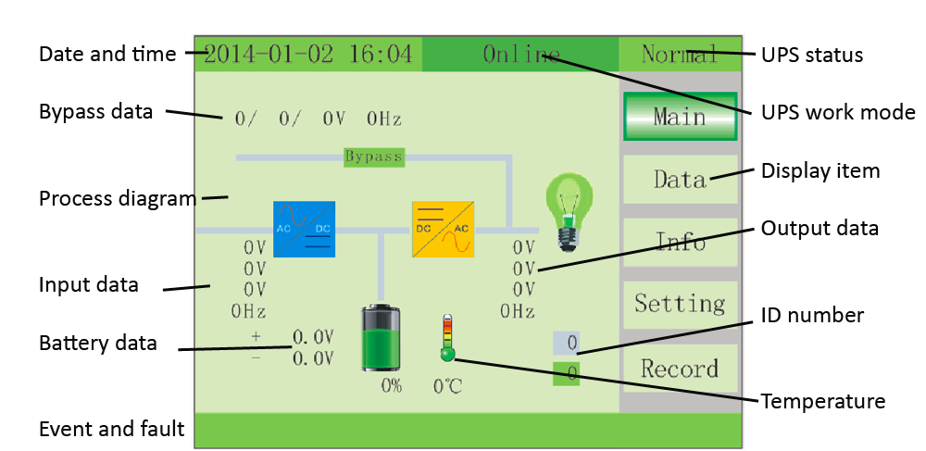side of the screen and press the enter key to enter the highlighted page.

Data : Press the scroll key for approximately 1 sec. to highlight Data. The Data page will display all
three phases of input and output voltage, current, and frequency and output load percentage as shown
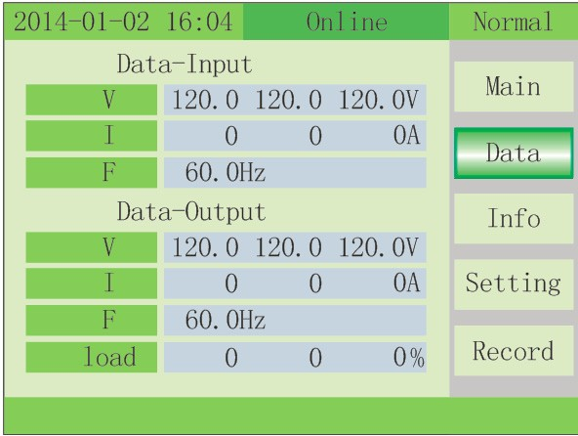below.

While in the Data page, additional data pages to view will be shown on the right side of the screen. Input: Press ENTER key for approximately 1 sec. The display will show all three phases of the Main
voltage, current, and frequency and the Bypass voltage and frequency as shown below.

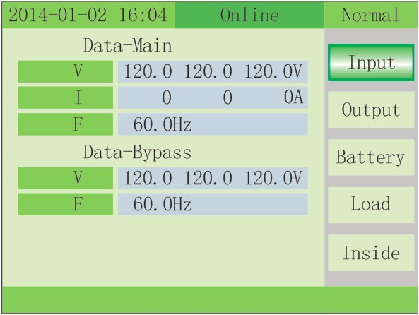
Output: Press the scroll key for approximately 1 sec. The display will show all three phases of the
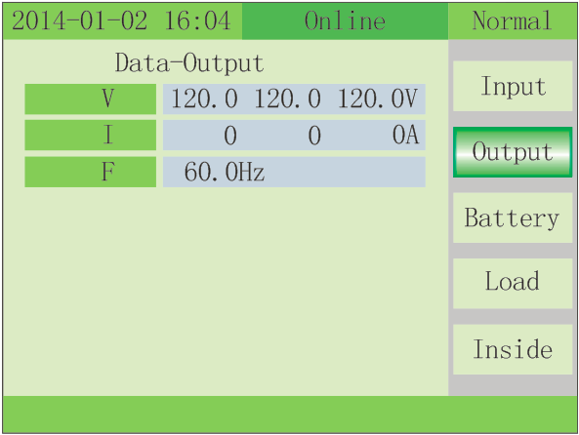Output voltage, current, and frequency as shown below.

Battery: Press scroll key for approximately 1 sec. The display will show the Battery voltage, current, estimated battery runtime and battery capacity as shown below.

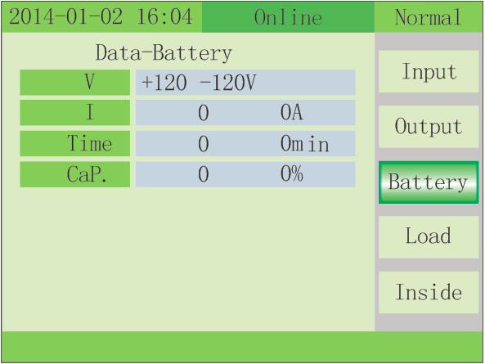
Load : Press the scroll key for approximately 1 sec. The display will show all three phases of the Load %, kW, and kVA as shown below

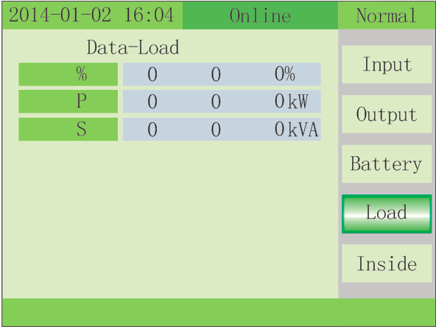

INSIDE: press key for approximately 1 sec. to move to the fifth page, the fifth page of data is Inside
data.

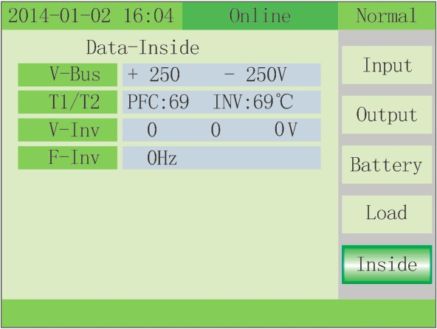Inside: Press the scroll key for approximately 1 sec. The display will show the internal V-BUS (DC bus voltage), T1/T2 (Temperature 1 and Temperature 2), V-Inv (Inverter Voltage), and F-Inv (Inverter Frequency) as shown below.

Info: Press the scroll key for approximately 3 sec. to exit Data, and press the scroll key for approximately
1 sec. move to Info. The display will show LCD, PFC, and INV software versions and power rating as
shown below.

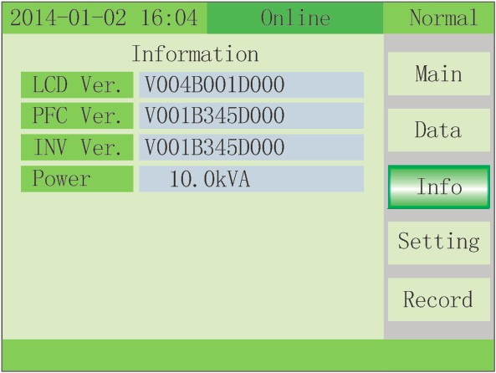
Setting: Press the scroll key for approximately 1 sec. to move to the setting page, then press ENTER key to enter setting-user page. Press the scroll key to change item, press ENTER key to enter item and press the scroll key to change value, press ENTER key confirm the setting.
Available settings are:

Setting | Values | Default
Language: | English, Portuguese, Italian, Deutsch, Polish, Spanish, or French | English
Backlight: | On, 10 – 100s in 10s increments | ON
Buzzer: | Enable or Disable | Enable
Test Now: | OFF, 10s, 10m, EOD -End Of Discharge | OFF

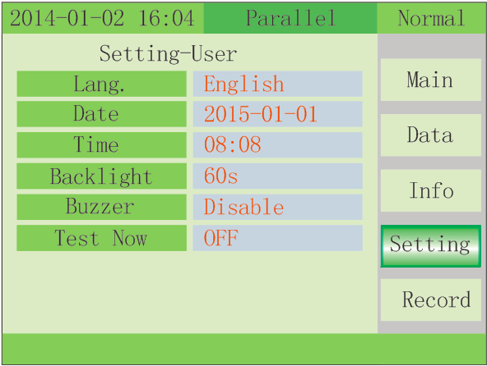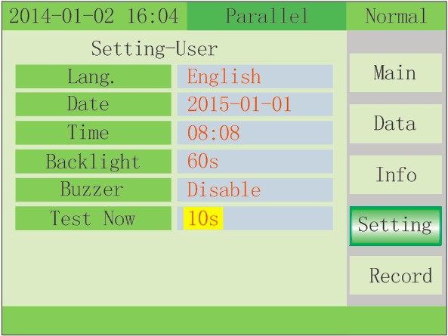Test Now: Press ENTER key to enter test now item, press the scroll key to select test value and press ENTER to confirm. The Battery manual test command can test battery discharge for 10s, 10min and to EOD.

Maintenance : Press + ENTER key to enter maintenance and display a password window, press change the number and press ENTER to select the value, the password is “1121”.

Record : Displays event records and fault records. Displays the Index (number in list), Time of event or fault, State (Mode) of UPS and event or fault as shown in the examples below.

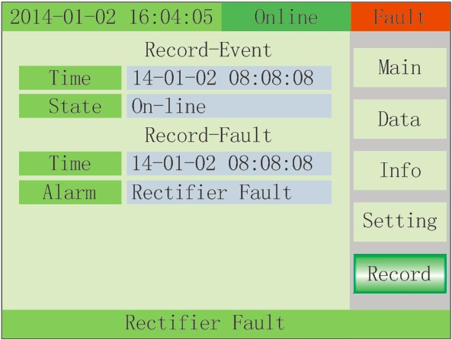Record-Event : Press the scroll key to select Up or Down or Delete. Press ENTER key to confirm. Record-Fault : Press the scroll key to select Up or Down or Delete. Press ENTER key to confirm. Note: If Delete is selected, all event or fault records will be deleted.

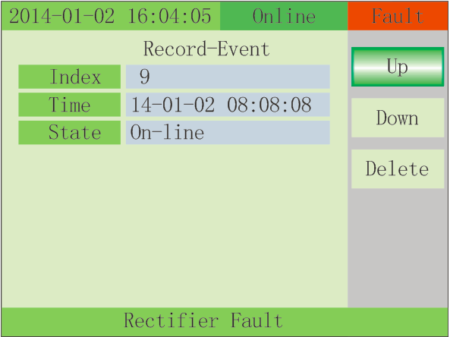

Maintenance: All system parameter setting are controlled by two keys, Scroll and Enter. Scroll - Moves through the parameters and adjusts values
Enter – Goes into setting pages and confirms values.

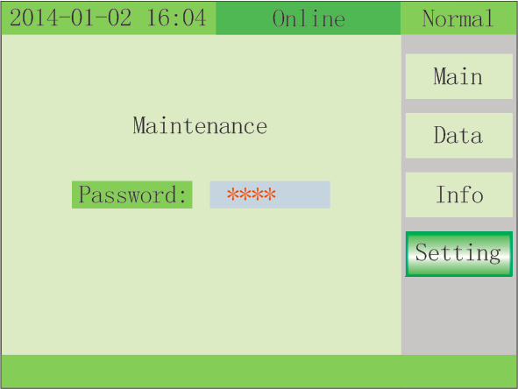To enter the Maintenance - System parameter setting mode, press the Scroll and Enter keys simultaneously for 3 seconds. The display will show a password window, press the Scroll key to change the number and press Enter to select the value, the password is “1121”.

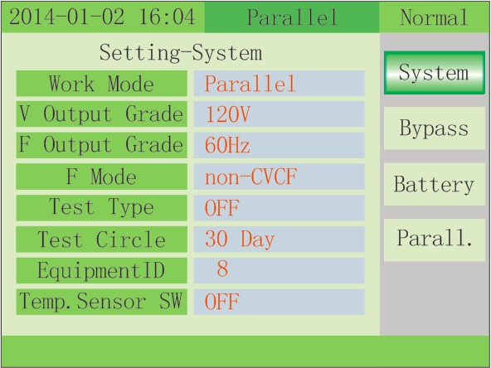Once the Maintenance password is entered, press the Enter key. The UPS goes into the Setting-System window as shown below.

Setting-System: press the Enter key to enter item and confirm value, press the Scroll key to change the value.

The following parameters can be adjusted:

Setting-System | Range | Default
Working Mode | Normal, Parallel, ECO | ECO1
V Output Grade2 | 120 or 127 | 120
F Output Grade3 | 50 or 60 | 60
F mode | CVCF or Non-CVCF | Non-CVCF
Test type | OFF, 10s, 10min or EOD | Off
Test Cycle | 1~30 days | 30 days
Equipment ID4 | 1 - 15 | 1
Temp. Sensor SW | ON or OFF5 | Off

1) Factory default setting for Working Mode is ECO. To disable ECO, reprogram Working Mode to Normal or
Parallel.
2) Must be in static bypass to change
3) If not in static bypass, output will drop load
4) This is the MODBUS device address used for RS232 & RS485 communication ports.
a. Press Scroll key to set the address.
b. When battery temperature sensor is open, choose ID 1~10 & 13~15
c. If UPS is set for parallel mode and device address <= parallel quantity, device address = parallel ID
d. Press “ON” to exit the device address setting and save the device address setting value and parallel ID setting.
e. Note: Under single UPS mode, until this device address setting save and exit, single UPS setting is done.
5) OFF turns off the sensor switch, ON turns on the sensor switch and send query command to sensor with
address 11 and 12 every second.

Press the Scroll key to highlight Bypass and press the Enter key to enter the Setting-Bypass window as shown
below.

Setting-Bypass: press the Enter key to enter item and confirm value, press the Scroll key to change the value.

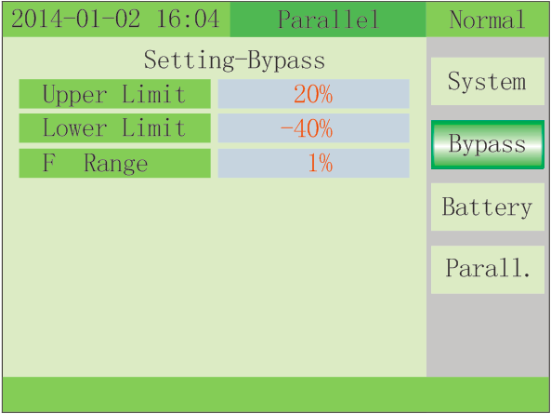The following parameters can be adjusted:

Setting-Bypass | Range | Default
Upper Limit | 10%, 15%, 20%, 25% | 25% VAC
Lower Limit | -10%, -20%, -30%, -40% | -40% VAC
F_Range | 1%, 2%, 4%, 5%, 10% | 10% HZ

Press the Scroll key to highlight Battery and press the Enter key to enter the Setting-Battery window as shown
below.

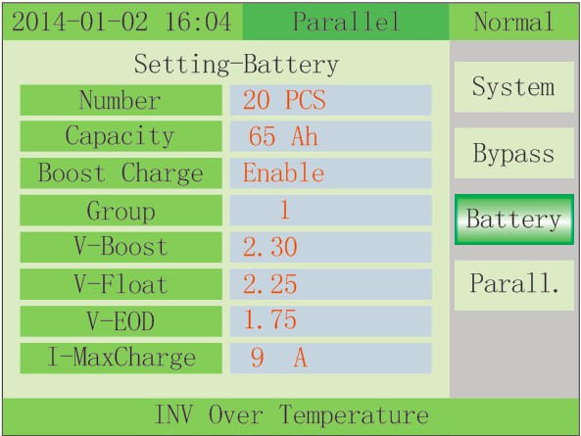Setting-Battery: press the Enter key to enter item and confirm value, press the Scroll key to change the value.

The following parameters can be adjusted:

Setting-Battery | Range | Default
Number1 | 20 | 20
Capacity2 | 7 - 2000 | 9AH
Boost Charge | Enable or disable | Enable
Group3 | 1-19 | 1
V-Boost | 2.30-2.40, step is 0.01V | 2.30 vpc
V-Float | 2.20-2.29, step is 0.01V | 2.27 vpc
V-EOD | 1.60-1.90V | 1.67 vpc
I-Maxcharge4 | 1-20A | Capacity x Group x .15

1. Number is the number of batteries per string
2. Capacity is the Amp-Hour rating of the batteries per string
3. Group is the number of strings of batteries
4. I-Maxcharge is the maximum charger current. Setting this above 15A on the E90-10kVA increases the input
current rating and requires an input circuit for 45A

Press the Scroll key to highlight Parallel and press the Enter key to enter the Setting-Parallel window as shown
below.

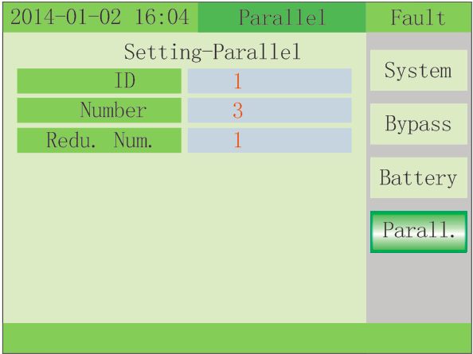Setting-Parallel: press the Enter key to enter item and confirm value, press the Scroll key to change the value.

The following parameters can be adjusted:

Setting-Parallel | Range | Default
ID1 | 1-4 | 1
Number2 | 1-4 | 1
Redu. Num3 | 1-3 | 0

1. ID - Program each UPS in Parallel with a unique ID
2. Number - Program the total number of UPS systems in parallel. Maximum of 4 in parallel.
3. Redu. Num. – Program to the total number of UPS systems in parallel to be used for redundancy

Parallel system commissioning
Warning: When UPS is working, the internal Bus capacitor stores a lot of energy. But isolated with mains cannot
guarantee completely no electricity inside the UPS and need extra attention when do the maintenance. When
cut off all the external input power supplied for maintenance, use the bleed resistor to release the energy stored
in Bus capacitor after open the case firstly to avoid causing injury to persons.
Please refer to the “UPS repair/maintenance”, especially the “Security maintenance conditions” and “ Close-
Disassembly/Reassembly UPS”.
Parallel system should be commissioning when the stand-alone are all intact.

Parallel system should be commissioning when the stand-alone are all intact.
Take 4 units in parallel for example.
1) Confirm the input/output wires connection and input phase sequence are correct; switch off the battery
breaker, and measure the +/- bat voltage of all battery group are normal.
2) Connect the parallel cable, it should be formed loop connection
3) Switch on the input breaker of unit 1,and access LCD setting interface to setting the working mode ID parallel
number redundant number. Require setting the in series number capacity of battery. The output voltage level
and Bypass protection range are default setting.
4) Turn off the input breaker of Unit 1, and make sure the UPS is off. Turn on the input breaker of Unit 2,access
the LCD setting interface, setting the parallel working mode, ID NO.2, parallel 4 units, redundant number .The
other setting are the same as UPS 1 operation.
5) For Unit 3 and Unit 4 UPS, the operation setting are all the same as Unit 1 and 2.
6) Turn on Bypass/input/output breaker of all the paralleled UPS, then confirm all the setting are correct. Each
UPS has their owed different ID.
7) Turn on all the battery breaker and confirm the parameter (V/I) are normal.
8) Connected the Load, and check whether the output current are balance.
Switch on and off the utility breaker to test all the UPS converters system from Utility to battery and restored
function are working find

Shutdown steps
1) Confirm the load information to avoid overload when turn off single unit;
2) Shut down each UPS according to the stand-alone UPS shutdown steps.

Emergency shutdown
Connect all the EPO ports to a key switch according to the following figure. When emergency occurs, switch on
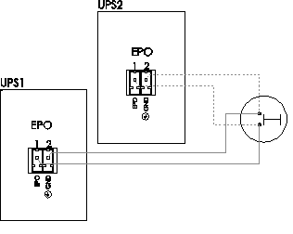the key can turn off all the outputs of UPS in this parallel system.

Software upgrade
There are two methods for software upgrade.

Use C2000 emulator to upgrade
When shutdown the UPS, remove the right panel of UPS, burn the DSP in control detection board
separately to upgrade. For detailed steps, please refer to the C2000 simulator instruction.

Use RS232 port to realize online upgrade
Remove the panel of the maintenance breaker, turn on the breaker so that the UPS goes to
maintenance bypass mode.
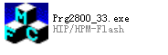Turn on the UPS with utility. Open the serial program software Prg2800_33.exe

Note:
a) When burning is finished, the other DSP cannot be burned until the DSP buzz. ( after burning INV,
about 5S later, the next burning can be performed. When finish burning the REC, the next burning can
be executed after about 20s).
b) If it fails during the REC burning, it will show “ Program was
unsuccessful”. Switch off the UPS and then restart, click “Update” to re-burn.
c) If it fails during the INV burning, it will show “Program was
unsuccessful”. Switch off the UPS and then restart, modify the ID number to 1 in the software. Close the
serial port and then open it, click “Re-Update” to start the re-burning.
d) During the burning, it repeats a frame data which goes into
an infinite loop. Restart the UPS and Prg2800_33 and check if the communication connection is ok.
Then re-burn can be operated. If it is the REC burning, please refer to the item b, if INV burning, please
refer to item c.
e) If the REC and INV burning are both fail, the INV burning
(Re-Update) has to be operated firstly. Cut off the mains and then power on the UPS, then the REC
burning (Update) can be executed.

Follow the settings in Figure (1)
“1” is to choose serial port that the computer uses;
“2” choose speed 9600;
“3” choose RS232;
“4” is to choose the ID number for the UPS that we are programmed. For single unit, it’s ID1, for parallel unit, it’s
the same as the ID number as we set in the UPS LCD.
“5” for laptop, pls set the value ≥5; for desktop computer, can set the value <5;
“6” choose 07;
“7” choose INV for the program, because we are going to update the inverter program; the same is REC program.
“8” is default value, no need to change;
“10”is for the target software “INV33.out”that we are going to program. pls note that you have to click “11” to
choose target upgrade file
After the setting done, pls click “Open device” as shown in Fig (1)
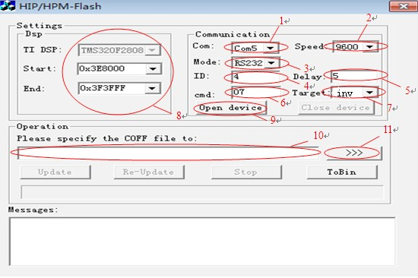e time, you can only use one of them at one time.

Figure(1)

After the above steps, it shows below Fig (2), pls click the “OK” button

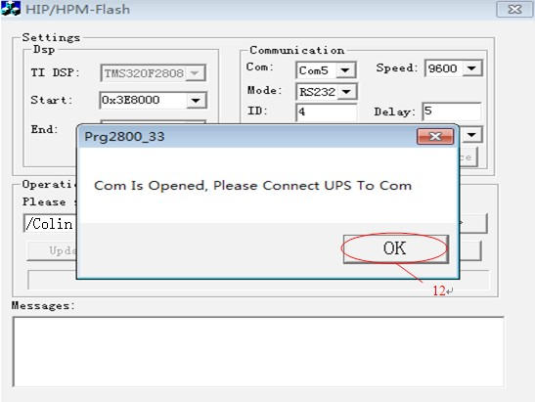
Figure(2)

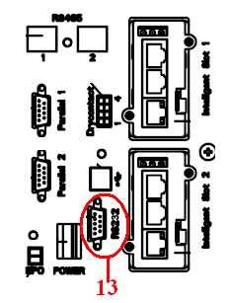Connect the UPS RS232 to the computer’s serial port, make sure the communication between them is good

Figure(3)

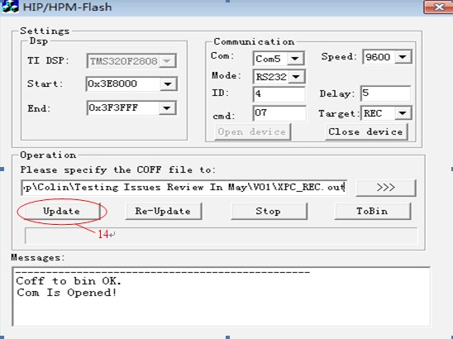After set up the communication between UPS and computer, click “Update” as shown in Figure (4)

Figure(4)

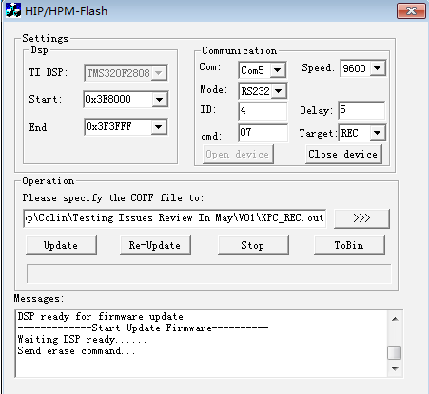Figure (5) shows the chip is preparing for the program

Figure(5)

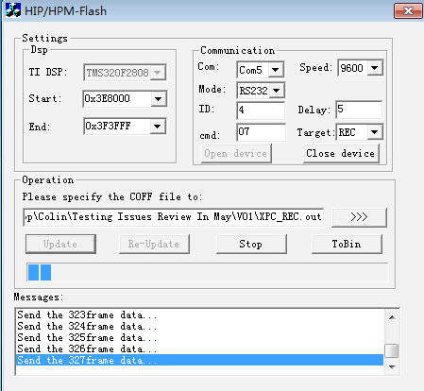Figure (6) shows the program work is proceeding

Follow below Figs 7/8/9 to finish and exit.
Figure(6)

If need go on the programming, pls return to step 3.
If finish and stop the programming, pls turn OFF the maintenance breaker, put on the panel, work the
UPS to inverter power supply.

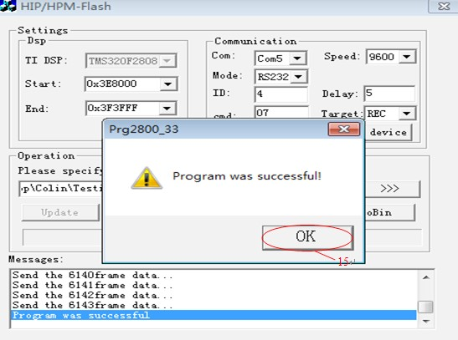
Figure(7)

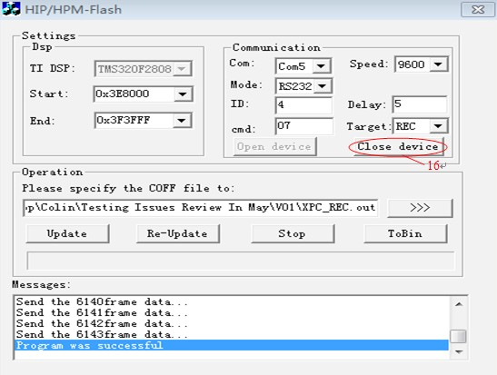
Figure(8)

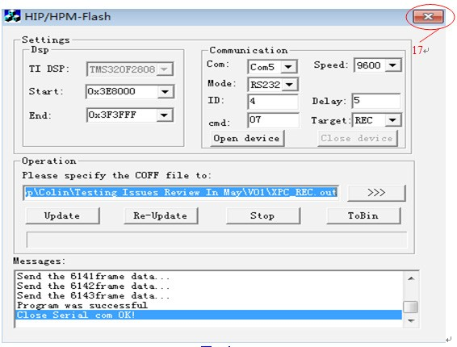
Figure(9)

Appendix A: UPS fault judgment
No. | UPS Alarm | Software judgment |  |  |  | Buzz | LED
No. | UPS Alarm | Condition 1 | Condition 2 | Condition 3 | Condition 4 | Buzz | LED
1 | Rectifier fault | DC BUS over- voltage | DC BUS under- voltage | Large bus difference |  | long  beep | Fault  ON
2 | Inv. fault(include Inv. Bridge arm ) | The absolute value of the output voltage >112.5% of rated output voltage, last 500ms |  | Bridge arm midpoint voltage( Inv. voltage) last 500ms >1.1 time of rat- ed peak value 360vfor230 344for220  376for240 |  | long  beep | Fault  ON
3 | Inv. SCR short |  |  |  |  | long  beep | Fault  ON
4 | Inv. SCR break | (in parallel, X phase load rate<6.3%) &&(parallel X phase total load rate>50%) &&(large loop current||in bypass mode) last time 2S |  |  |  | long  beep | Fault  ON
5 | Bypass SCR  short | (X phase Output voltage>60% of rated) &&(the absolute values of other phases voltage<5% of rated voltage) last 2s |  |  |  | long  beep | Fault  ON
6 | Bypass SCR  break | ((in parallel, X phase load rate <6.3%) &&(parallel X phase total load rate<50%) &&(large loop current|| in Bypass mode) ) ||(X phase cur- rent>10% of rated&&X phase Output voltage>50% of the Bypass voltage) last 2S |  |  |  | long  beep | Fault  ON
7 | Fuse broken | Hardware signal low available |  |  |  | long  beep | Fault  ON
8 | Parallel Relay  fault | ( Inv. status&&Relay open) ||(no Inv. Status && parallel Relay close) last  20ms |  |  |  | long  beep | Fault  ON
9 | Fan fault | Hardware signal low available for 5s |  |  |  | long  beep | Fault  ON
10 | Reserve |  |  |  |  | long  beep | Fault  ON
11 | Auxiliary power  fault | Hardware signal  low available for  3ms |  |  |  | long  beep | Fault  ON
12 | Power initializa- tion fault | 1) Rec.DSP read IIC self-test, until 15s power on) Inv. DSP read IIC self- test, until 15s delay unit not obtain valid parameter from E2PROM, jumper error, jumper type is not defined, DSP internal RAM self-test error(MCU cannot completely modify RAM) |  |  |  | long  beep | Fault  ON
13 | Positive bat- tery Charge fault |  |  |  |  | long  beep | Fault  ON
14 | Negative bat- tery Charge fault |  |  |  |  | long  beep | Fault  ON
15 | Bus over-volt- age | +bus voltage>470V Last time:  20ms | -bus voltage  >470V  Last time:  20ms |  |  | long  beep | Fault  ON
16 | Bus under- voltage | Bus volt- age <280V time:120ms | Bus voltage is 10V lower than setting value Time: 2min |  |  | long  beep | Fault  ON

No. | UPS Alarm | Software judgment |  |  |  | Buzz | LED
No. | UPS Alarm | Condition 1 | Condition 2 | Condition 3 | Condition 4 | Buzz | LED
17 | Large differ-  ence between  ±Bus | 30V difference between ±bus |  |  |  | long  beep | Fault  ON
18 | Soft start fail | 10s later, soft start bus volt- age is lower than 300V | During the soft start, ±bus voltage <1.2 times of in- put voltage for 120ms |  |  | long  beep | Fault  ON
19 | Rectifier over-  temperature | Last 0.2s>77°C show PFC over temperature |  |  |  | twice/s | Fault  ON
20 | Inv. Over-tem-  perature | Last 0.2s>77°C show inverter over tempera- ture |  |  |  | twice/s | Fault  ON
21 | Input neutral loss |  |  |  |  | twice/s | Fault  ON
22 | Battery reverse | +battery volt- age< -50V | -battery volt- age >+50V |  |  | twice/s | Fault  ON
23 | Parallel con- nection fault | Parallel cable fault under the parallel : 10ms |  |  |  | twice/s | Fault  ON
24 | CAN communi- cation fault | Parallel number more than 1 for single unit and powered UPS is no more than 1 unit |  |  |  | twice/s | Fault  ON
25 | Share current when parallel fault |  |  |  |  | twice/s | Fault  ON
26 | Battery high voltage | Setting Charge voltage +20V |  |  |  | once/s | Fault  flash
27 | Input phase sequence reverse | Obtain by algorithm |  |  |  | once/s | Fault  flash
28 | Bypass reverse | Obtain by algorithm |  |  |  | once/s | Fault  flash
29 | Output short  circuit | X phase Output voltage is lower than rated 30%&&X phase Out- put current is 70% of rated current |  |  |  | once/s | Fault  flash
30 | Rectifier over-  current |  |  |  |  | once/s | Fault  flash
31 | Bypass over-  current | X phase Bypass Output current greater than the rated 125% |  |  |  | once/s | BPS  flash
32 | Over load | X phase load rate( Inv. or Bypass) greater than rated 105% |  |  |  | once/s | INV or BPS flash

33 | No battery | Battery voltage lower than 50V |  |  |  | once/s | BAT- TERY flash
34 | Battery voltage  low | Battery voltage lower (EOD voltage*6*battery pcs) |  |  |  | once/s | BAT- TERY flash
35 | Low battery pre-alarm | Battery EOD voltage+(battery pcs *6(SetJarNum) *1.5) |  |  |  | once/s | BAT- TERY flash
36 | Internal com- munication error | Comm. Error between Recti- fier and Inv. |  |  | once/2s | Fault  flash
37 | Inv. DC exces-  sive | DC component average value is more than 2V last 2S |  |  |  | once/2s | INV  flash
38 | Overload in parallel | X phase load rate is more than total load rate of parallel system:  400ms |  |  |  | once/2s | INV  flash
39 | Mains voltage  abnormal | Higher than  270V | Lower than  182V |  |  | once/2s | BAT- TERY ON
40 | Mains frequen- cy abnormal | Higher than  70Hz | Lower than  38Hz |  |  | once/2s | BAT- TERY ON
41 | Bypass ultra protection | Bypass power down and not available |  |  |  |  | BPS  flash
42 | Bypass ultra tracking | Bypass abnormal but powered, and bypass instantaneous nor- mal, then change the Bypass to ultra tracking |  |  |  |  | BPS  flash
43 | Start invalid | 1) rectifier not start completely or start fault a) over-tempera- ture b) fan fault c) SCR fault and shutdown d) bridge arm short and shutdown e) power board fault f) software fail g) battery re- verse and shutdown h) user operation fault(maint. Bypass close) i) Auxiliary power power down and shutdown 2) manually start invalid
44 | Reserve
45 | Inverter not on
46 | Output switch not ON |  |  |  |  | Once per  3 seconds

